
Syrian Arab Republic
Syrian Private University
Faculty of Informatics Engineering
Department of Information Engineering –
Software Engineering and Information Systems

Software System for Managing an Agricultural Facility (Poultry Farming)

Prepared by
Majed Jammoul - Alaa Karma

Supervision
Dr. Fadi Ibrahim

Academic Year
2024/2025
Supervisor's Acknowledgment

I certify that the preparation of this project tagged
is a software system for the management of an agricultural facility (poultry farming).
Prepared by the students:
Majed Jammoul – Alaa Karma
I have been under my supervision in the Department of Software and Information Systems Engineering – College of Computer, Informatics and Communication Engineering, which is part of the requirements for obtaining a bachelor's degree in Software and Information Systems Engineering.
Scientific Rank.................... Name............................ Signature

History

Abstract

This project aims to develop an intelligent software system for the management of an agricultural facility specialized in poultry farming, in order to provide an integrated and safe environment to follow up daily operations, and to improve production efficiency and data quality.
The system focuses on meeting the needs of farmers and administrators by facilitating inventory control, feeding and grafting scheduling, growth and production tracking, as well as sales and reporting management.
The objectives of the project include:
- Creating a reliable and secure system that protects data from any cyber threat.
- Easy user interface design that supports the daily work of the farm.
- Integrate the system with publishing tools and reports for accurate and transparent follow-up.
The project goes through the following phases:
- Analysis: Requirements collection and workflow analysis within the poultry facility.
- Design: Develop a system structure plan using UML models and databases.
- Implementation: System development using modern technologies such as React and Node.js.
- Testing: Checking the efficiency and security of the system, and ensuring that it is compatible with the needs of users.

This system contributes to transforming the management of poultry farms from the traditional method to the digital method, which contributes to raising productivity, reducing waste and improving the quality of management decisions.

Tables Index:
Table 1: User Data Management Use Case Description 41
Table 2: Description of the use case of modifying system settings 42
Table 3: Description of the use case of monitoring activity logs for monitoring the use of system 43
Table 4: User Data Management Use Case Description (Add/Modify/Delete) 45
Table 5: Description of the use case for generating production and profit reports based on available data 46
Table 6: Description of the use case of resource planning and scheduling (e.g., food and fuel) 47
Table 7: Description of the use case of sending new orders to merchants 47
Table 8: Describe the use case of performance data analysis to identify opportunities for improvement and make strategic decisions 47
Table 9: Description of the use case of veterinary examination recording for individual and group cases 52
Table 10: Description of the use case of follow-up prevention and treatment plans 53
Table 11: Use Description Providing Recommendations to Improve the Health Environment within the Facility Error! Bookmark not defined.
Table 12: Use case description of the provision of specialized nutrition plans to ensure the health and growth of poultry 55
Table 13: Description of the use case of recording daily poultry feed data 57
Table 14: Description of the use case of reporting abnormalities via simple forms 58
Table 15: Facility Hygiene Status Update Use Case 58
Table 16: Description of the use case of assistance in sorting operations 59
Table 17: Description of the use case of assistance in packing operations 60
Table 18: Use Case Description of Adding Food Supply Details 61
Table 19: Direct Quote Use Case 62
Table 20: Application Status Update Use Case Description (Delivered/Not Delivered) 63
Table 21: Description of the use case of the Food Consumption Report 55 64
Table 22: Description of the use case of recording the amount of fuel supplied in each operation. 65
Table 23: Describe the use case of reporting any delivery issue. 66
Table 24: Description of the use case for providing periodic reports on fuel consumption. 67
Table 25: A use case description of recommendations to improve fuel efficiency and reduce costs. 68

Charts Index
Activity Diagram: 21
User Data Management Activity Chart: 22
System Settings Modification Activity Chart: 22
Activity chart to monitor activity logs to track system usage: 23
Production and Profit Reports Activity Chart: 24
Resource Planning and Scheduling Activity Plan: 24
Merchant Purchase Orders Activity Chart: 25
Performance Data Analysis Activity Chart: 27
Veterinary Examination Registration Activity Chart: 28
Prevention and Treatment Plans Follow-up Activity Plan 30
Outline of Recommendations for Improving the Healthy Environment: 30
Activity plan for the presentation of specialized food plans: 31
Daily Nutrition Data Recording Activity Chart: 32
Abnormal Reporting Activity Chart: 33
Facility Cleanliness Status Update Activity Plan: 33
Sorting and packing assistance activity diagram: 34
Activity Chart for Adding Details of Supplies Supplied: 34
Live Bidding Activity Plan: 35
Status update activity chart: 35
Food Consumption Reporting Activity Chart: 36
Activity chart of the amount of fuel supplied in each operation: 36
Activity chart for reporting any delivery issue: 37
Fuel Consumption Periodic Reporting Activity Plan: 37
Activity plan for making recommendations to improve fuel efficiency and reduce costs: 38
Use Case Diagram: 40
System Admin Use Case Chart: 41
Facility Manager Use Case Chart: 44
Veterinarian Use Case Chart: 48
Employee Use Case Chart: 56
Food Merchant Use Case Chart: 61
Fuel Dealer Use Case Chart: 64
Sequence Diagram: 69
Sequence diagram of the admin (modifying system settings) process: 69
Sequence diagram of the admin (Add-Delete-Modify ) user data management process: 70
Sequence Diagram of the Admin's (Monitoring Activity Logs to Follow up on System Usage) Process: 71
Sequence Chart of the Process (Generation of Production and Profit Reports) of the Facility Manager: 71
Sequence Diagram of the Facility Manager's (Resource Planning and Scheduling) Process: 72
Sequence Chart of the Process of ( Sending New Orders to Merchants ) of the Facility Manager: 72
Sequencing Diagram of the Process of ( Analyzing Performance Data to Make Strategic Decisions ) of the Facility Manager: 73
Relay Diagram of the Veterinarian's (Individual /Group Veterinary Examination Registration) Process: 73
Sequence chart of the veterinarian's (follow-up of prevention and treatment plans): 74
Sequence diagram of the veterinarian's (making recommendations to improve the health environment): 74
Sequence Chart of the Veterinarian's (Specialized Nutrition Plans) Process: 75
Sequence Chart of the Employee's (Daily Poultry Feed Data Recording) Process: 75
Sequence Diagram of the Employee's (Reporting Abnormalities through Simple Forms) Process: 76
Sequence Diagram of the Employee's (Facility Hygiene Status Update) 76
Sequence diagram of the employee's (assistance in sorting and packing processes when preparing poultry for sale): 77
Sequence Chart of the Food Merchant's (Bidding) Process: 77
Relay Chart of the Food Merchant's (Order Status Update) Process: 78
Relay Chart of the Food Merchant's (Food Consumption Report) Process: 78
Sequence Chart of the Fuel Dealer's (Recording of Fuel Quantities) Process: 79
Relay Diagram of the Food Merchant's (Report Delivery Problem) Process: 79
Sequence Diagram of the Food Merchant's Fuel Consumption Report Process: 80
Sequence Diagram of the Food Merchant's (Recommendations to Improve Fuel Efficiency) Process: 80
Class Diagram: 81
Components Diagram: 82
Planner :ERD 83

Table of Contents
Chapter One : Introduction 8
Introduction to the project topic: 9
Justifications: 9
Project Objective: 9
Chapter Two: Research Topic and Reference Study 10
Introduction: 11
Future Forecast: 11
Reference Study: 11
Summary of Interviews: 13
Chapter Two: Analytical Phase of the Proposed Regulations 15
Feasibility: 16
Economic Feasibility of the Project: 16
Social feasibility of the project: 16
Legal feasibility of the project: 16
Methodology Used: 16
Stages of the Cumulative Gradual Development Methodology: 16
1. Functional Requirements: 18
2. Non-functional requirements: 20
Table of Actors and Use Cases: 39
Textual Description of Use Cases: 41
1. The admin logs in to the system 41
2. Select from the main menu "Manage Users" 41
3. The system displays a list of all 41
4. The admin chooses one of the following options (add - delete - modify) 41
5. The admin chooses the user he wants to manage his data 41
6. Add, modify, or delete as it wants 41
System Architecture: 81
Tools used: 83

Vocabulary table

Term | Abbreviation | المصطلح بالعربية | Brief Explanation
Poultry Farming | - | تربية الدواجن | Agricultural sector for raising birds for meat and eggs12.
Software System | - | نظام برمجي | Software components for digital facility management13.
User Interface | UI | واجهة المستخدم | The medium through which users interact with the system45.
Unified Modeling Language | UML | لغة النمذجة الموحدة | Graphical models for planning system and database structure67.
Database | DB | قاعدة بيانات | Organized storage for facility data like inventory and production68.
Incremental Development | - | التطوير التراكمي | Methodology of building and integrating system units sequentially69.
Functional Requirements | - | المتطلبات الوظيفية | Operations and tasks the system must perform for users1011.
Non-functional Requirements | - | المتطلبات غير الوظيفية | System quality attributes like security, performance, and flexibility1012.
Economic Feasibility | - | الجدوى الاقتصادية | Studying project profitability and website impact on performance1013.
Social Feasibility | - | الجدوى الاجتماعية | Studying website impact on community communication1014.
Legal Feasibility | - | الجدوى القانونية | Ensuring website compliance with applicable laws and regulations1014.
System Admin | - | مدير النظام | Person responsible for managing users and general settings1115.
Facility Manager | - | مدير المنشأة | Responsible for production reports, profits, and resource planning1115.
Veterinarian | Vet | الطبيب البيطري | Responsible for healthcare and preventive plans for poultry1516.
Employee | - | الموظف | Responsible for recording daily feeding and hygiene data1517.
Food Supplier | - | تاجر المواد الغذائية | Supplier responsible for feed details and price quotes1518.
Fuel Supplier | - | تاجر الوقود | Supplier responsible for fuel delivery and consumption reports1518.
Use Case Diagram | - | مخطط حالات الاستخدام | Diagram showing interaction between actors and system functions1519.
Activity Diagram | - | مخطط النشاط | Describes the workflow within various system processes2021.
Sequence Diagram | - | مخطط التتابع | Illustrates the timed interaction between components for a process1522.
Class Diagram | - | مخطط الأصناف | Represents the software structure and object relationships2324.
Entity Relationship Diagram | ERD | مخطط علاقات الكيانات | Model showing database tables and their relationships723.
Model View Controller | MVC | هيكلية النموذج-العرض-المتحكم | Architectural pattern dividing the app for easier development7.
Application Programming Interface | API | واجهة برمجة التطبيقات | Allows data exchange and communication between systems2526.
Hypertext Markup Language 5 | HTML5 | لغة توصيف النص | Standard for developing modern interactive web pages2627.
Cascading Style Sheets 3 | CSS3 | لغة تنسيق الصفحات | Used for designing and formatting the appearance of web pages28.
JavaScript | JS | لغة جافا سكريبت | Programming language for building interactive web applications626.
React | - | رياكت | Library for building scalable and interactive user interfaces626.
Node.js | - | نود جي إس | Runtime environment for executing JavaScript on the server side626.
Express.js | - | إكسبريس جي إس | Lightweight framework for building web apps and APIs29.
MongoDB | - | مونغو دي بي | Non-relational (NoSQL) database storing data as documents58.

Chapter One: Introduction

Introduction to the project topic:
The project addresses a software system for the management of a poultry farming facility and its role in improving the efficiency of operations and increasing productivity. The project aims to develop an integrated platform that facilitates the management of various aspects of the facility, such as monitoring bird health, nutrition management, scheduling activities, and production tracking. The platform supports interaction between employees in the facility through an easy-to-use interface to improve decision-making and ensure the sustainability of production.

Justifications:
Traditional poultry farming facilities suffer from significant challenges, such as the difficulty of efficiently managing resources, the inability to accurately monitor birds, as well as limitations related to immediate interaction between workers. Many of the current software systems also suffer from poor customization of solutions to meet the specific needs of each facility, lack of support for data analysis and decision-making, and lack of integration with modern technological tools such as sensors.

Project Objective:
This project aims to study the impact of the software system on improving the efficiency of poultry farming facility management and developing operational process monitoring methods. It also seeks to develop a software platform characterized by accuracy, customization, and ease of use, with a focus on meeting the needs of different facilities and supporting data-driven decision-making to improve productivity and ensure the sustainability of operations.

Chapter Two: Research Topic

and the reference study

Introduction:
In light of the digital revolution and the continuous development of information and communication technology, it has become necessary for the productive sectors, especially the agricultural sector, to adopt smart and advanced systems that contribute to improving efficiency and productivity. Poultry farming is one of the most important branches of agricultural production that requires careful monitoring and effective management of various elements such as health care, nutrition, temperature, ventilation, and daily production.
Based on the increasing successes of e-learning technologies and smart software in improving the performance of educational and training institutions, it is wise to employ the same principles in the agricultural sectors through flexible and up-to-date digital systems that enable facility owners to monitor and operate operations efficiently through smart electronic platforms. The proposed software system for the management of a poultry farming facility is a paradigm shift in traditional management methods, as it provides tools for recording and analyzing data, issuing automatic alerts, and providing periodic reports that support the adoption of decision, which contributes to reducing costs, increasing returns, and improving the quality of production.

Future Prospects:
- Growth in demand for products: The demand for poultry products is expected to witness a continuous increase, which will enhance the growth opportunities for the facility.
- Digital market expansion: E-commerce will continue to grow, pushing agricultural enterprises to strengthen their digital presence and increase their investments in digital marketing
- Increased environmental awareness: As awareness of sustainability issues increases, enterprises will move towards more sustainable poultry farming practices, which can impact business operations

Reference Study:
In order to ensure that our project will meet the needs of users, we reached out to a number of people who own poultry farms and asked a number of questions and will now present the results of the interviews:

First Interview:
Youssef | Name of the person or establishment:
The site must include a sales management system | What are the basic features you need in the website?
Better Having an Easy User Interface | How would you prefer the information to be displayed?
yes | Do you need a notification system?
Difficulty tracking the health status of poultry | What challenges are you currently facing?

Second Interview:
Name of the person or establishment: | Firas
What are the basic features you need in the website? | Poultry Health Data Management System
How would you prefer the information to be displayed? | Information should be presented in an orderly and uncomplicated manner
Do you need a notification system? | Yes, of course, especially in tracking deaths.

Third Interview:
Name of the person or establishment: | Mohammed
What are the basic features you need in the website? | Temperature Monitoring System
How would you prefer the information to be displayed? | The information must be presented in an orderly manner
Do you need a notification system? | Yes, of course, especially in temperature tracking.
What challenges are you currently facing? | Difficulty managing data in general

Fourth Interview:
Name of the person or establishment: | Ahmed
What are the basic features you need in the website? | Employee Work Management System
How would you prefer the information to be displayed? | I prefer having a special section for employees
Do you need a notification system? | Yes, of course especially in tracking workers' performance
What challenges are you currently facing? | Difficulty in organizing work among employees

Summary of the interviews:
After the study we presented above, we noticed a disparity in the problems suffered by the owners and managers of the establishments, and this creates a challenge for us to prove the merit of our project in satisfying all users.

Chapter Three: The Analytical Stage

of the proposed system

Feasibility:

Economic feasibility of the project:
Poultry farming is a lucrative agricultural activity, and with the increasing reliance on technology in agriculture, creating an agricultural enterprise website becomes essential. This economic study aims to analyze the economic feasibility of a website and its impact on the performance of the establishment.

Social feasibility of the project:
The website of an agricultural poultry farming facility is a vital tool to enhance communication between the facility and the local community. This social study aims to analyze the impact of the site on the community from various aspects.

Legal feasibility of the project:
Websites are an essential part of modern business, and running a website for a poultry farm requires adherence to a number of laws and regulations. This study aims to highlight the key legal aspects to consider.

Methodology Used:
Incremental development is an information systems development method that divides the entire system into functional units or small increments that are built and integrated sequentially at specific stages of time. In each development cycle, a usable component or set of components is produced, so that the final system evolves gradually and acquires more functionality with each iteration.

Stages of the Cumulative Gradual Development Methodology:
- Increment Planning:
The overall system is broken down into small increments or parts that are developed at specific intervals. In this stage, priorities are set for the core functions that need to be delivered first as well as the implementation sequence is defined so that each increment has a complete and independent value.
- System Architectural Design: A
general architectural model is developed to ensure that all increases are compatible later. The design includes drawing the structural plans of the system and identifying the main units that allow future increases to be seamlessly integrated.
- Design and plan the details of the new increase:
For each increase, a detailed design is prepared that shows how the added functionality will be achieved in that cycle. During the design, it is taken into account that it is adjustable as needed based on future observations or changes in requirements.
- Implementation (Unit Development):
The development of the new unit or addition based on the detailed design using appropriate programming languages and techniques. The application of quality and testing standards is taken into account during the writing of the code while incorporating the principles of clean programming.
- Individual Testing and Integration Testing:
The unit developed is individually tested to ensure that there are no functional or technical errors, and then integration testing is performed to ensure that the new unit is compatible with the existing kernel and the rest of the system.
- Integration of the increase into the main system and conducting comprehensive testing:
After passing the unit and integration tests, the increase is integrated into the general system, and user acceptance testing is conducted to ensure that all new functions are working according to the required specifications.
- Evaluation and Feedback Collection:
The updated version is presented to stakeholders for feedback gathering and feedback. This feedback is analyzed to determine if additional adjustments or improvements are needed in future cycles.
- Iteration and development of the following increments:
The cycle continues by repeating the steps from design to implementation and testing for each new increment. This iteration ensures that the system progressively evolves with more functionality according to the chosen priorities.
- Final Deployment, Follow-up and Maintenance:
After all planned increases are completed and confidence in the quality of the system is achieved, the entire system is deployed. Regular maintenance and update practices are also followed based on system usage and operational feedback to ensure continuity of performance.

System Requirements:

Functional Requirements:
- Functional Requirements for System Admin:
- Manage user data (add/modify/delete).
- View system settings.
- View work units and sections.
- Monitor activity logs to keep track of system usage.

- Functional Requirements for the Facility Manager:
- Create production and profit reports based on available data.
- Resource planning and scheduling (food - fuel).
- Request feed from a food dealer.
- Request for vaccines and medicines from the veterinarian.
- Ordering equipment from the equipment dealer.
- Send new orders to merchants.
- Assign a new agent.
- Track performance data analysis to identify opportunities for improvement and make strategic decisions.
- Submit a recommendation to improve activity logs.
- Send a recommendation to improve production (feed quantity – number of eggs produced).
- Submit a recommendation to improve the consumption of the facility's resources.

- Functional Requirements for the Veterinarian:
- Recording veterinary examinations for individual and group cases.
- Follow-up of prevention and treatment plans.
- Provide recommendations to improve the healthy environment within the facility.
- Providing specialized nutrition plans to ensure the health and proper growth of poultry.
- View and print the report log.

- Functional Requirements for the Employee:
- Recording daily poultry nutrition data.
- Report abnormalities through simple forms.
- Updating the facility's cleanliness status.
- Assisting with sorting and packing processes when preparing poultry for sale.
- View and print sorting and packing processes.
- View and print dealer and veterinary doctor's reports.
- Modify the reports received from the dealers and the veterinarian.

- Functional Requirements for Food Merchant:
- Adding details of the food items supplied (quantity - quality).
- Direct quotes through the system.
- Edit and delete quotes.
- Update the status of previous orders (Delivered – Not Delivered).
- Provide reports on food consumption to determine future quantities required.
- Editing, deleting and printing food consumption reports.

- Functional Requirements for Fuel Dealer:
- Record the amount of fuel supplied in each process.
- Report any delivery problem.
- Provide periodic reports on fuel consumption.
- Provide recommendations to improve fuel efficiency and reduce costs.
- Editing, deleting and printing fuel status reports.

Non-Functional Requirements:
- React provides a component design that can be easily expanded.
- Supports Node.js efficient resource management, even as data volume increases.
  - Security:
- Data encryption techniques can be used during client-server (TLS/SSL) communication.
- Node.js allows permissions control for system users such as (admin and administrator).
  - Performance:
- React ensures fast and interoperable interfaces.
- Node.js processes orders quickly without causing delays or system suspensions.
  - Flexibility:
- React supports quick interface updates such as adding new functions.
- Node.js allows the database to be modified and software changes easily.
  - Portability and compatibility:
- The system can work on different types of devices thanks to the modern design of the user interface.
- Node.js ensures system compatibility with multiple databases such as MongoDB or MySQL.
  - Reliability:
- React and Node.js contribute to building a stable and responsive system.

Activity Diagram:
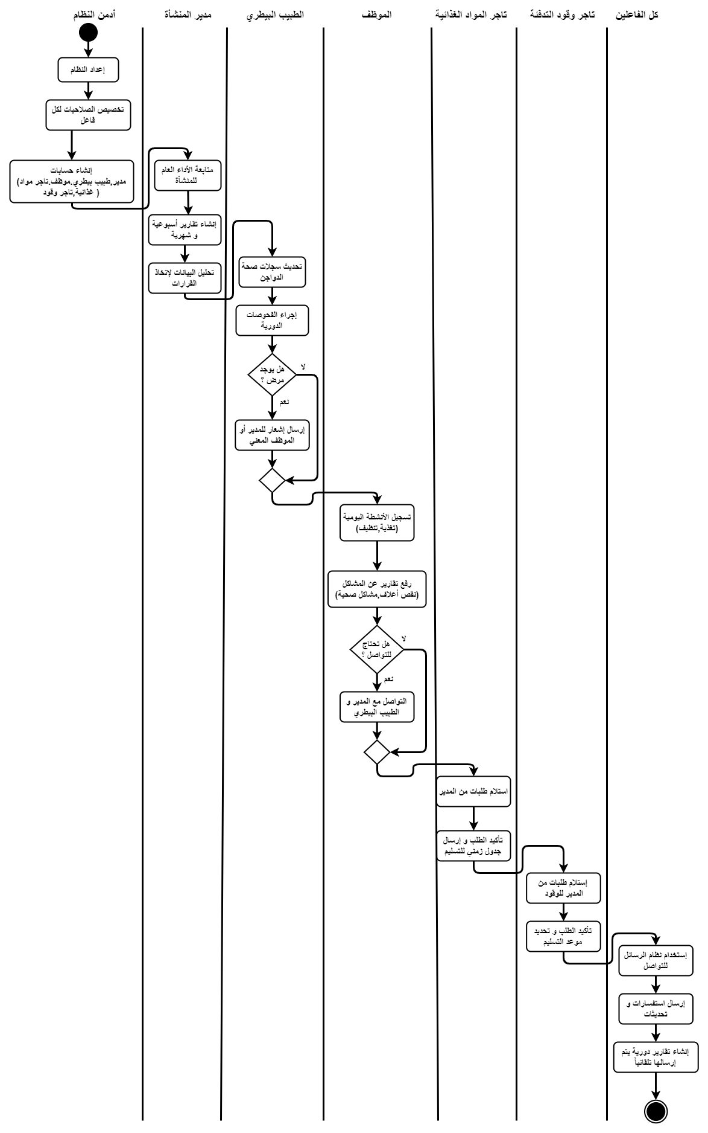

Activity Diagram of Users Data Management:
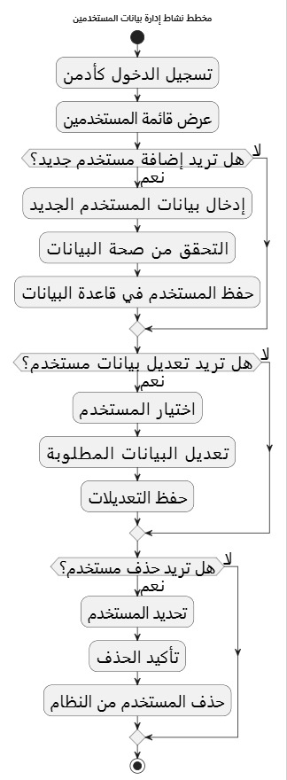

Activity Diagram of System Settings Modification:

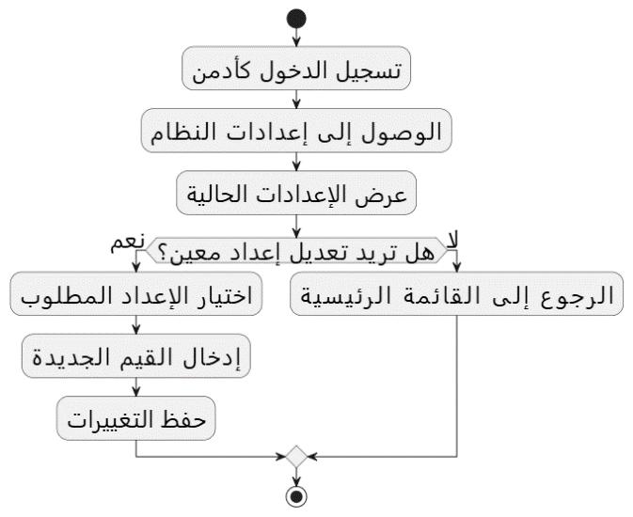

Activity Diagram of Track System Usage:
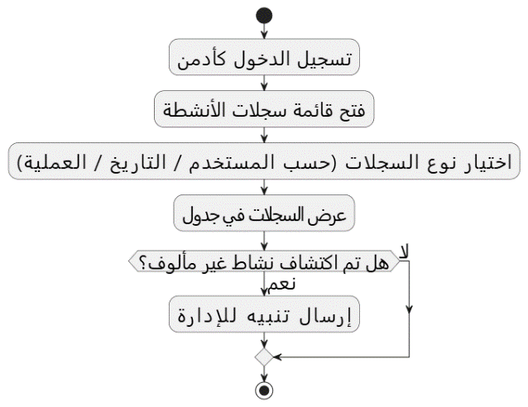

Activity Diagram of Production and Profit Reports:

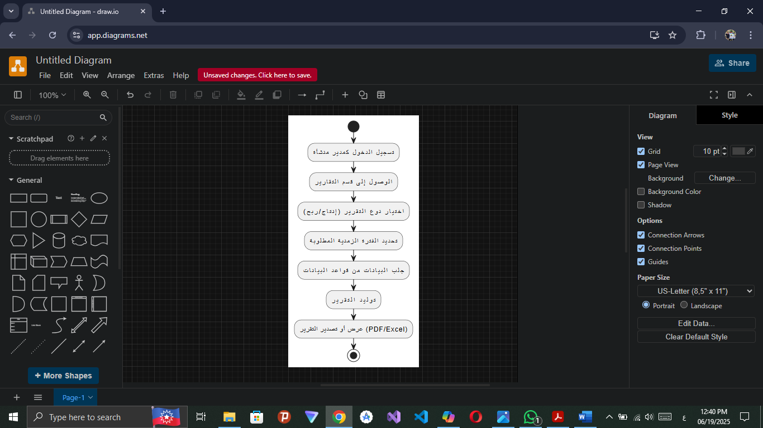

Activity Diagram of Resources Planning and Scheduling:
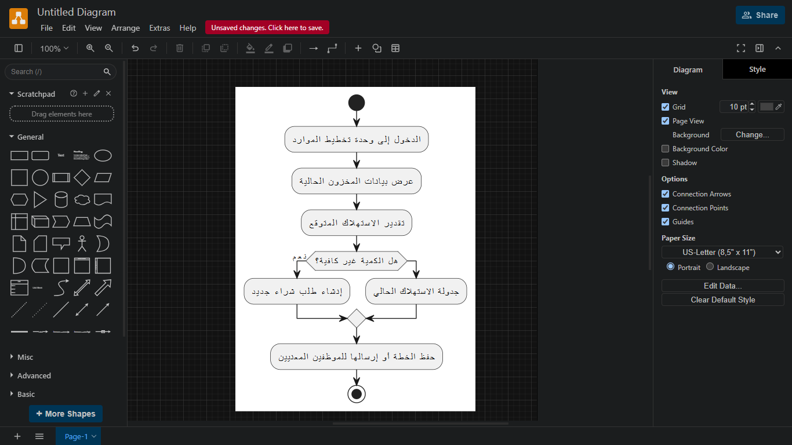

Activity Diagram of the activity of ordering feed from the food dealer:

Activity Diagram of requesting vaccines and medicines from the veterinarian:

Activity Diagram of Equipments Ordering from Equipment Dealer:

Activity Diagram of sending new orders to merchants:
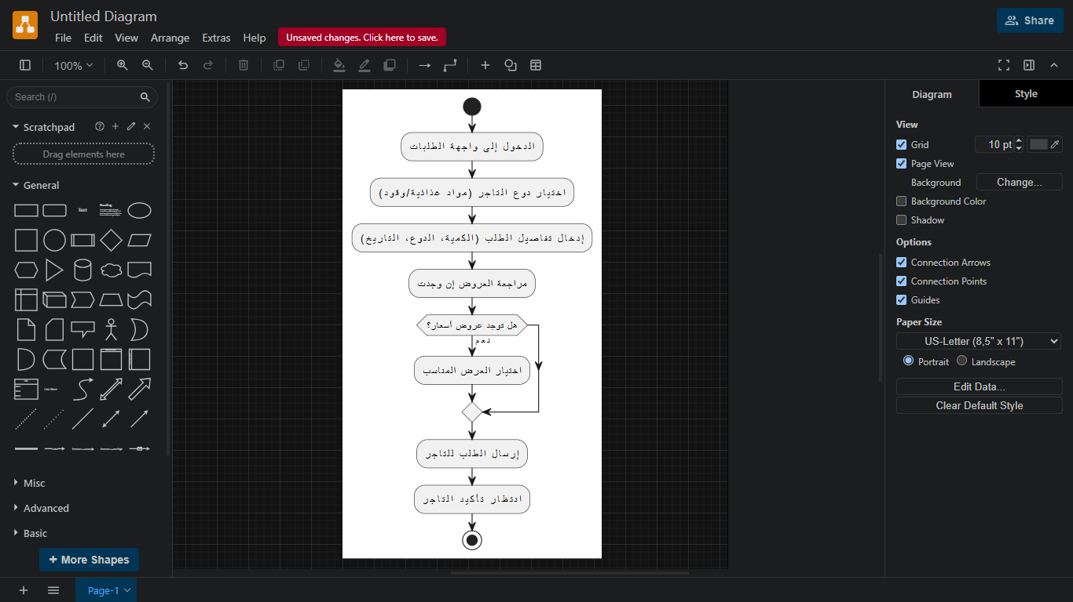

Activity Diagram of assigning a new worker:

Activity Diagram of Performance Data Analysis Tracking:
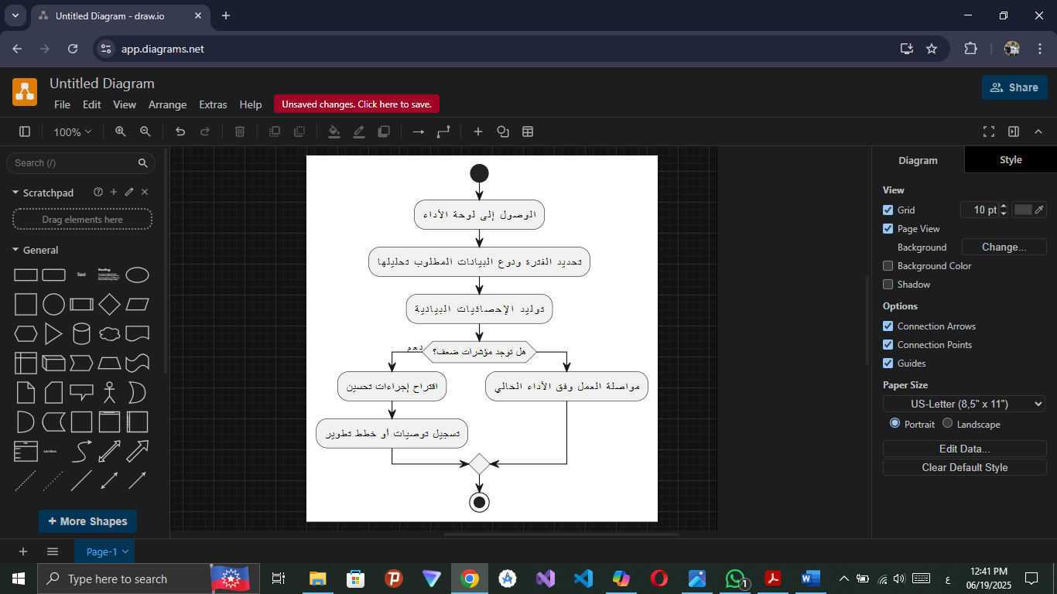

Activity Diagram of Sending a recommendation to improve activity logs:

Activity Diagram of Sending a recommendation to improve production:

Activity Diagram of Sending a Recommendation to Improve Enterprise Resources:

Activity Diagram of Veterinary Examination Registration:

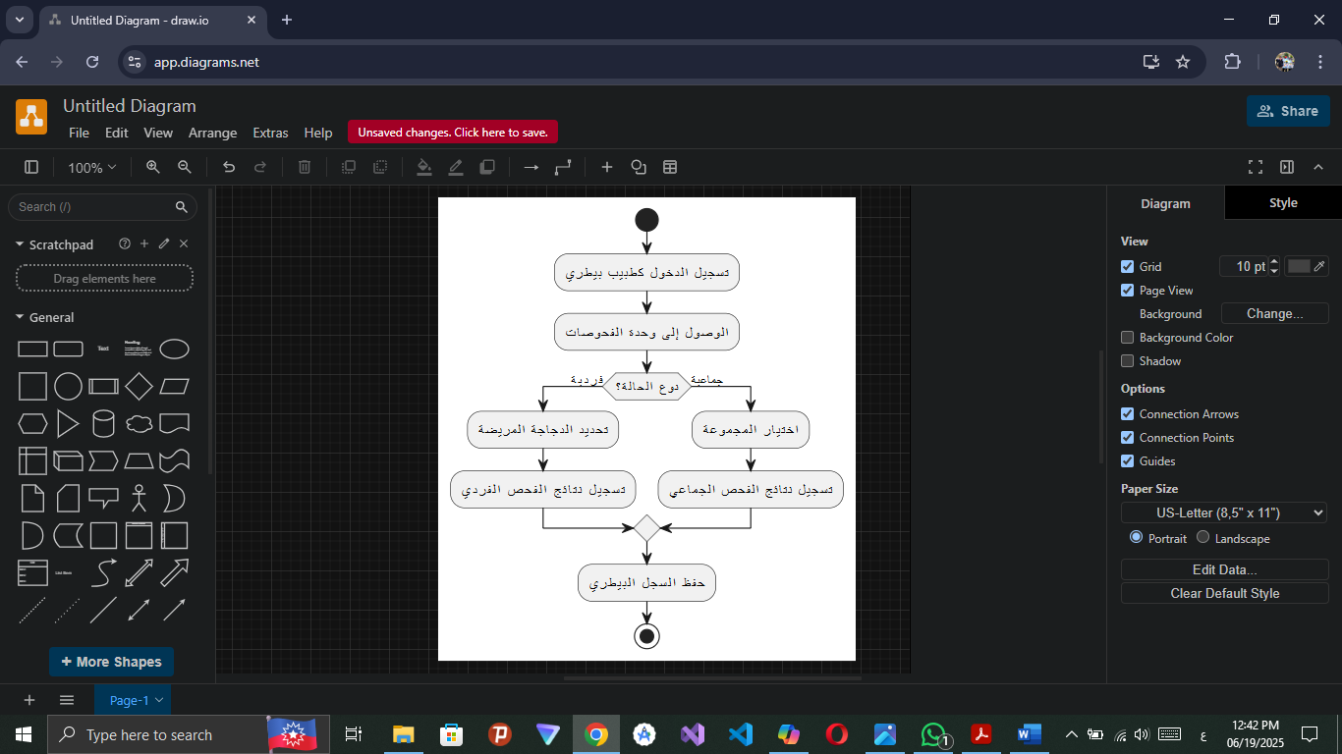

Activity Diagram Prevention and Treatment Plans Follow-up:
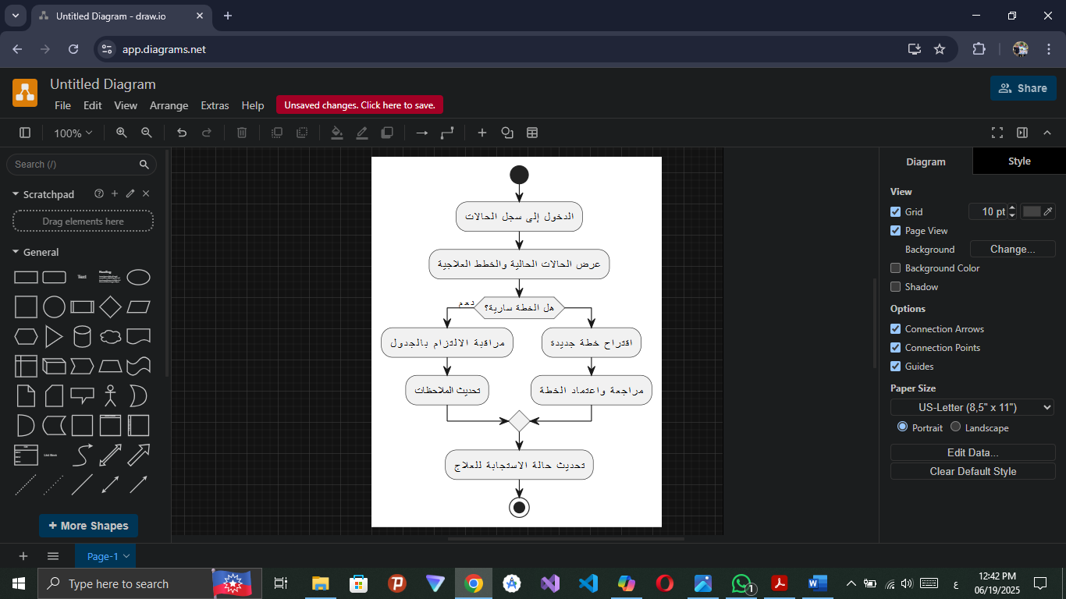

Activity Diagram of the Recommendation Activity to Improve the Healthy Environment:

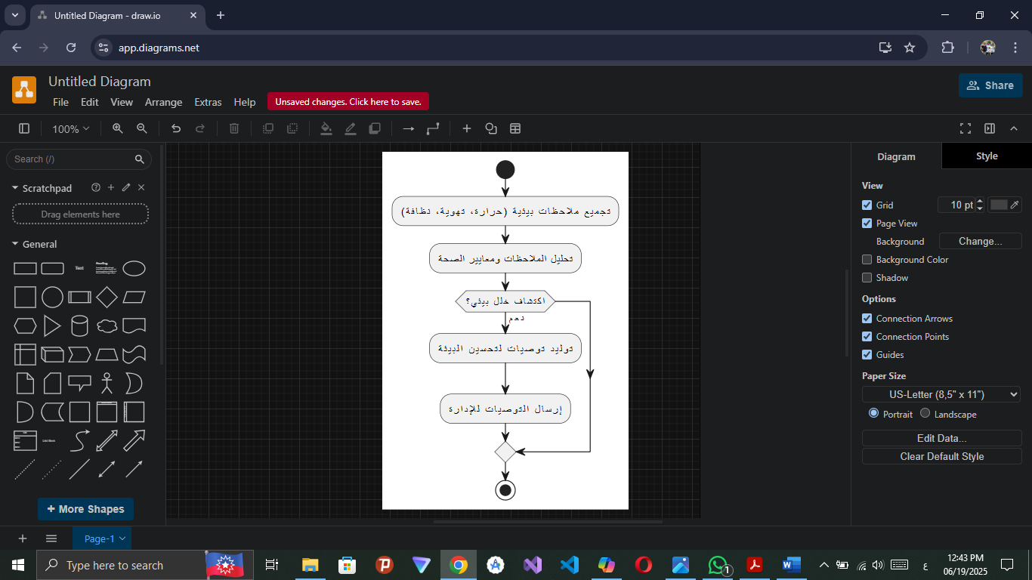

Activity Diagram of providing specialized food plans:
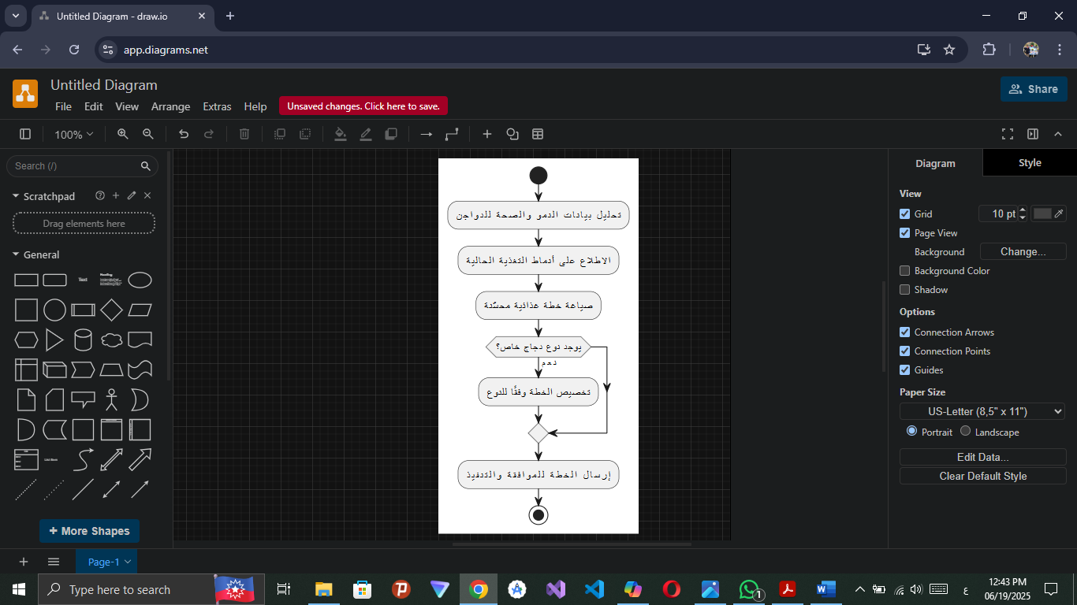

Activity Diagram of viewing and printing the report log:

Activity Diagram of Daily Nutrition Data Recording:

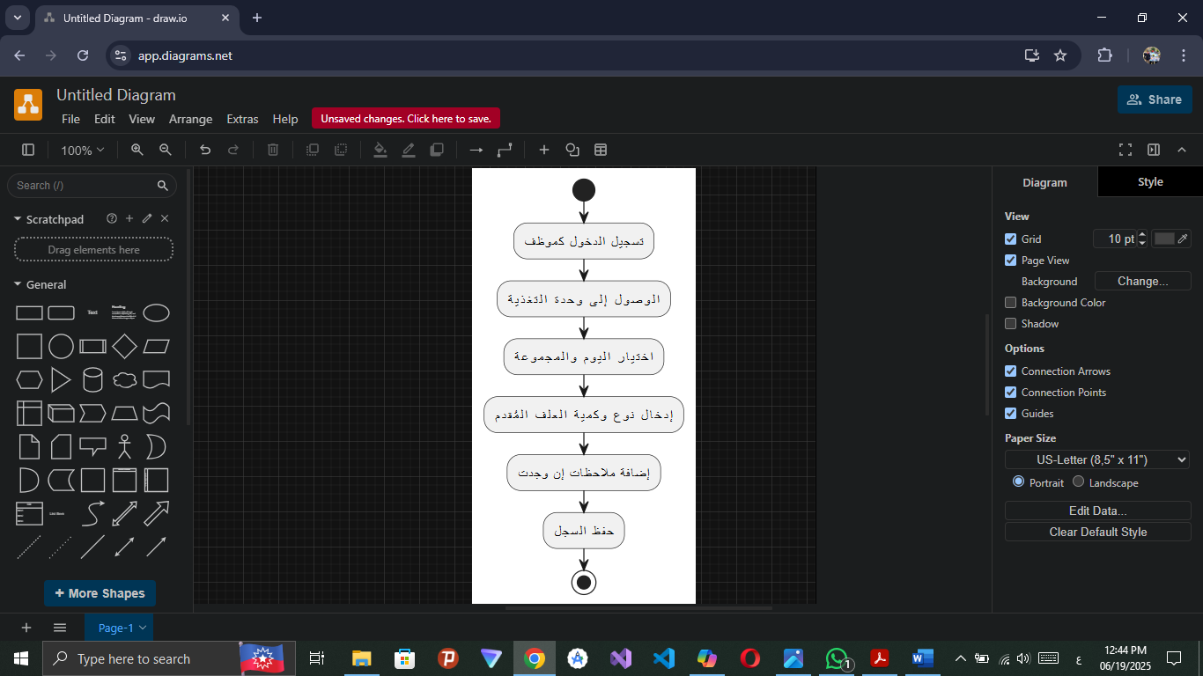

Activity Diagram of Abnormal Cases Reporting:
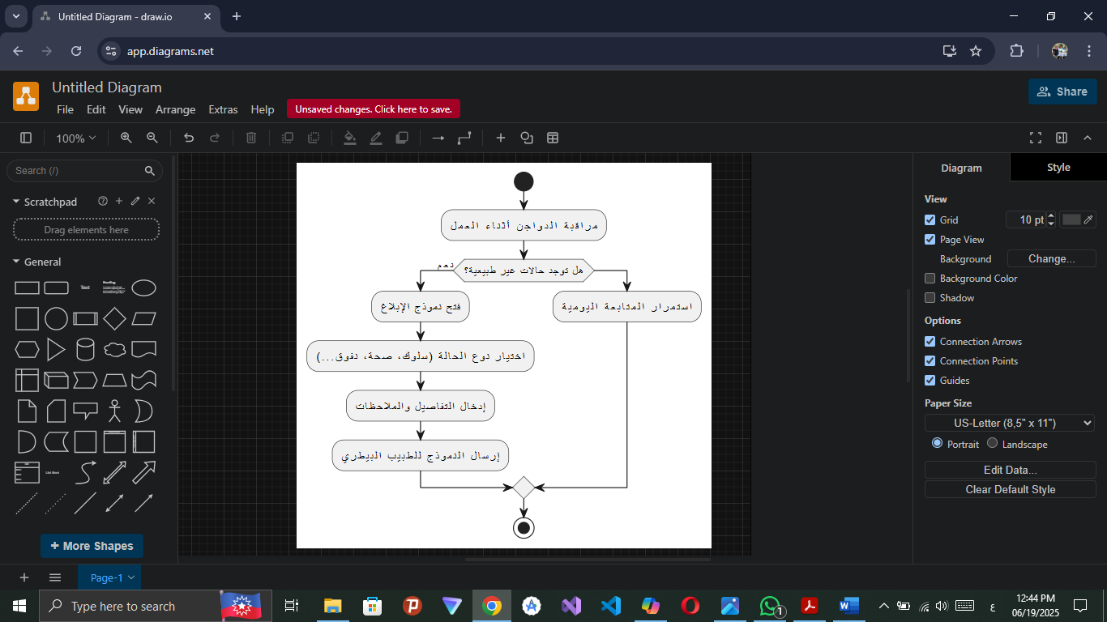

Activity Diagram of Facility Cleanliness Status Update:
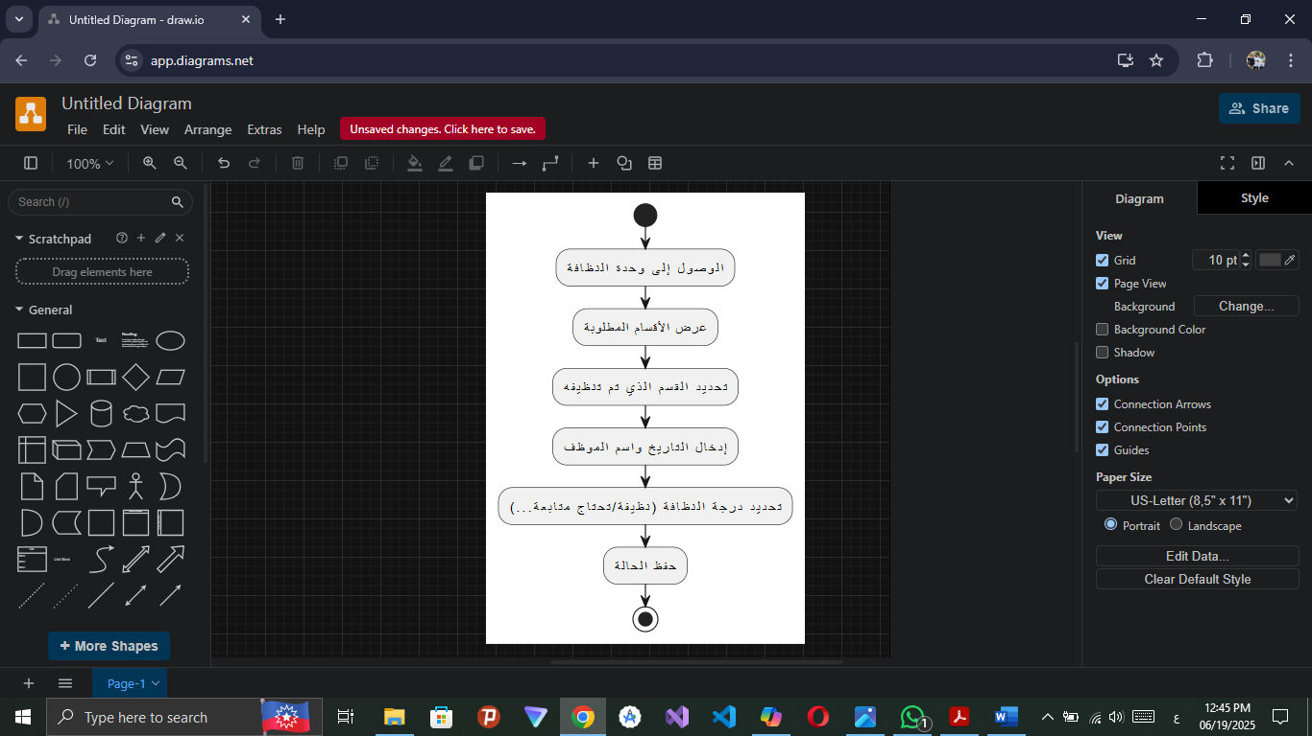

Activity Diagram of help with the sorting and packing process:
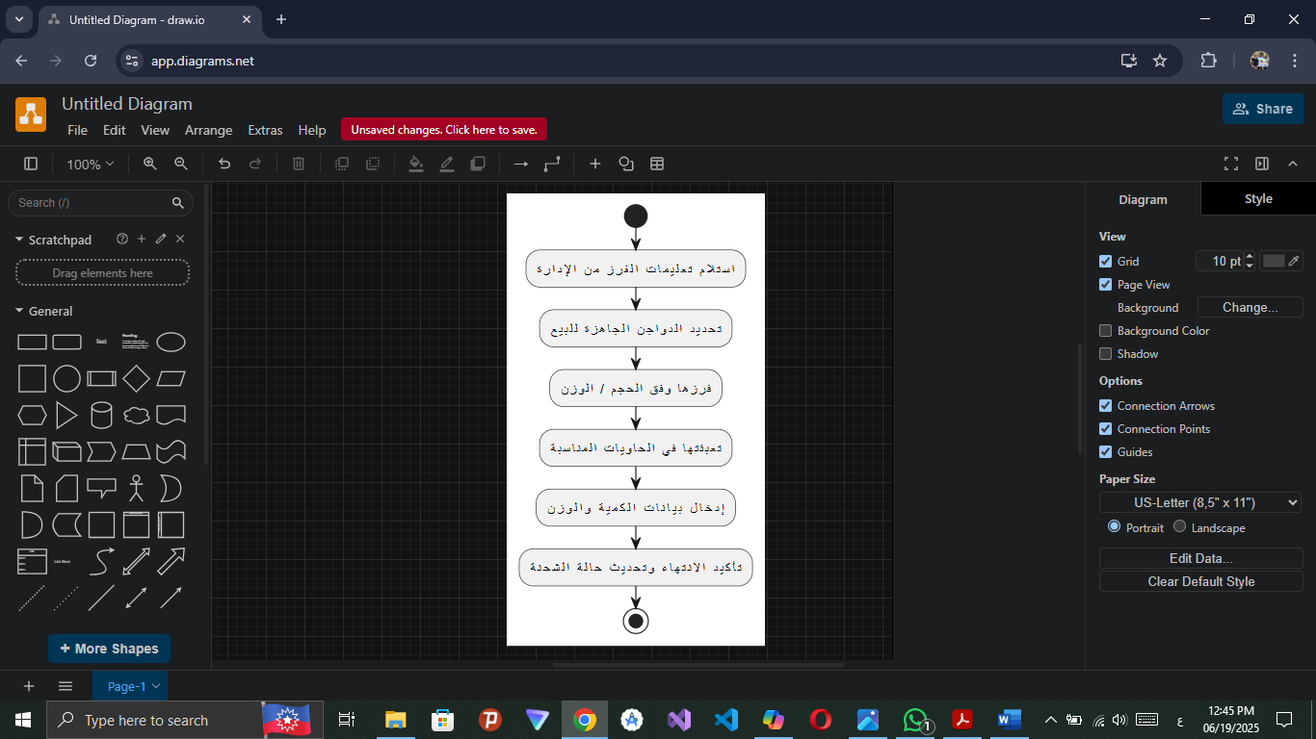

Activity Diagram of Printing And Display Sorting Processes:

Activity Diagram of Display And Print Reports Of Suppliers:

Activity Diagram of Editing Reports of Suppliers:

Activity Diagram of Adding Details of Supplies:

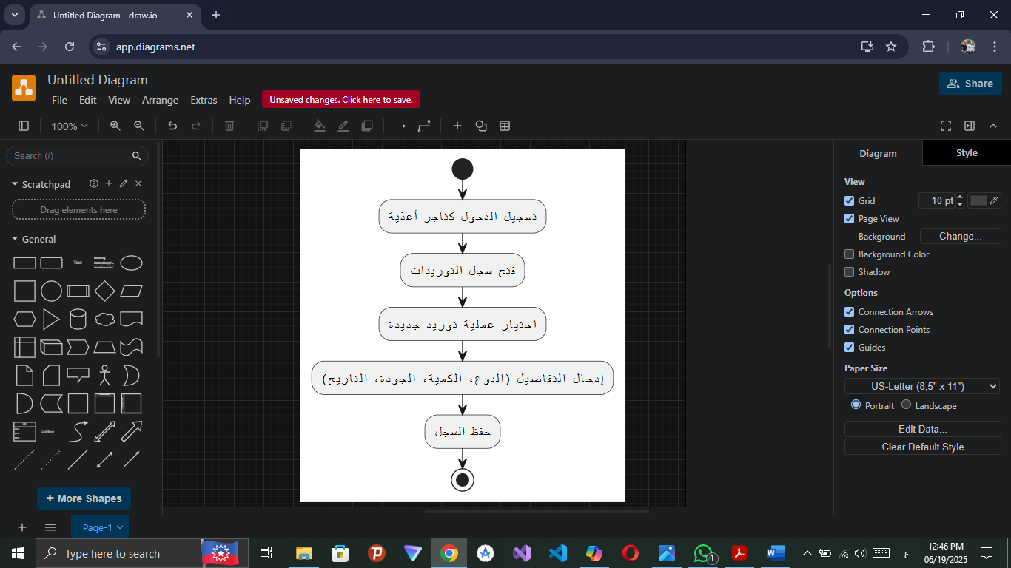

Activity Diagram of Live Bidding:
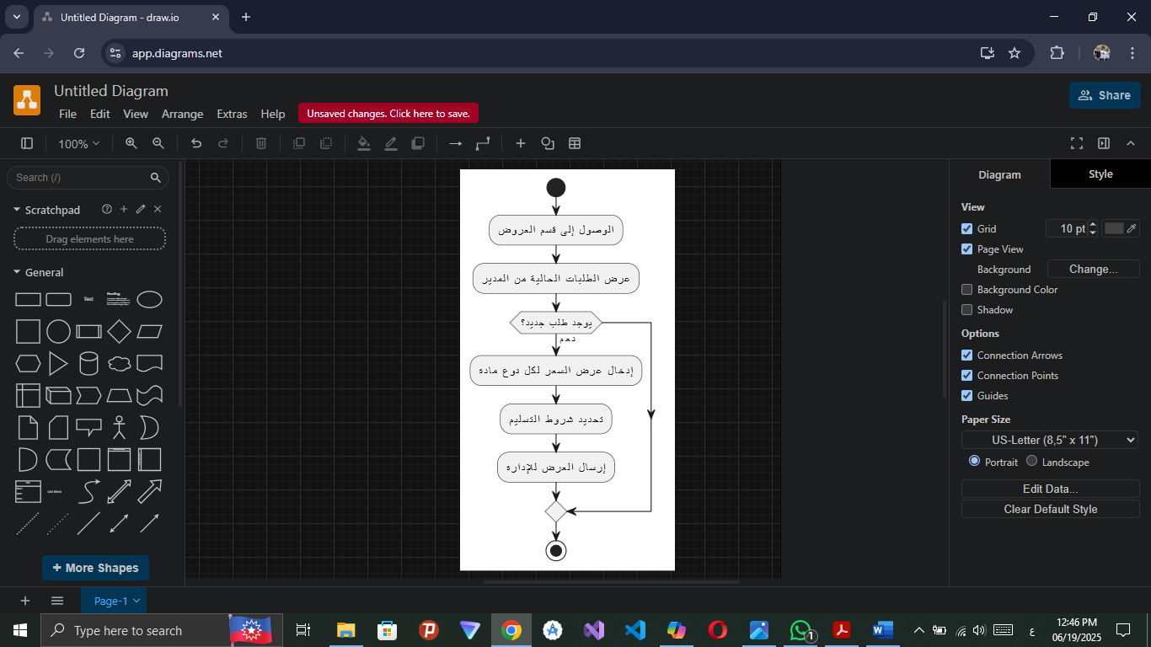

Activity Diagram of Editing And Deleting Prices Offers:

Activity Diagram of Past requests status update:

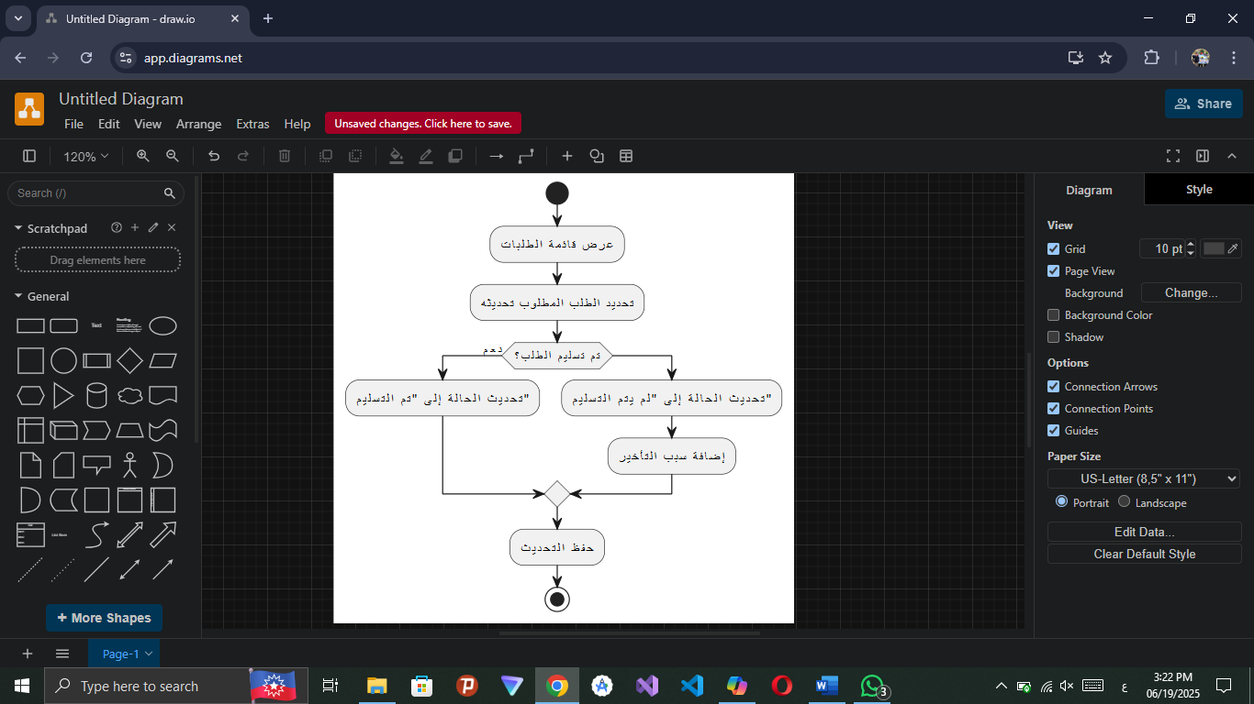

Activity Diagram of Food Consumption Reporting:
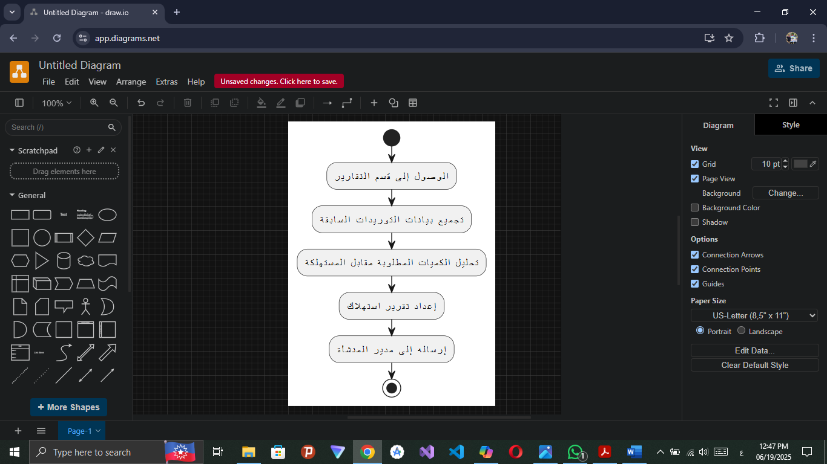

Activity Diagram of Editing And Deleting Food Consumption Reports:

Activity Diagram of recording the amount of fuel supplied in each operation:

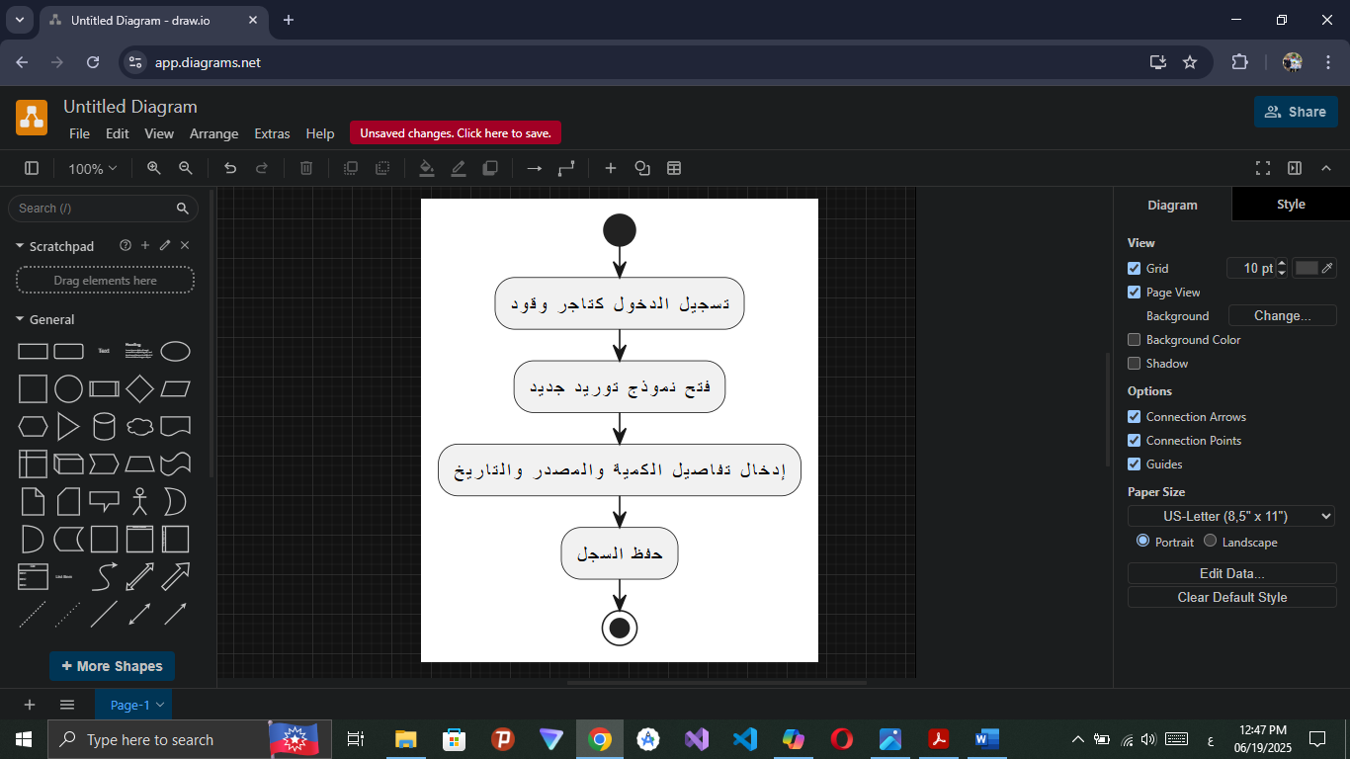

Activity Diagram of reporting any delivery issue:
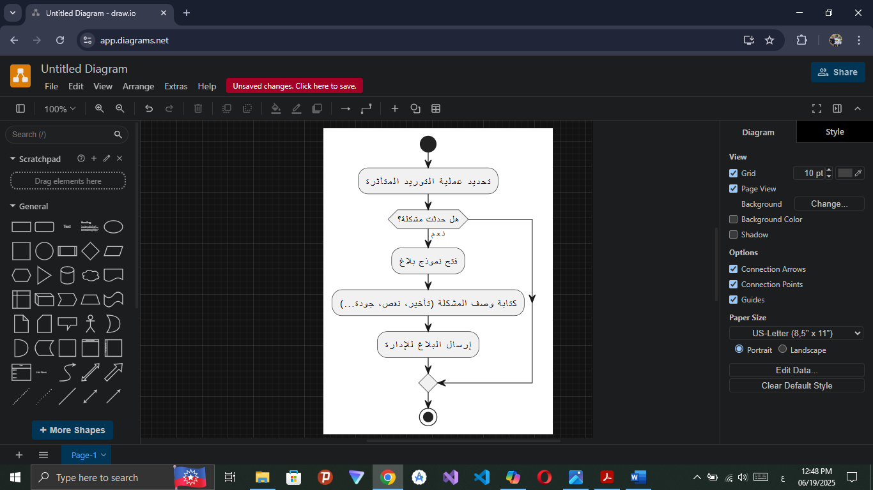

Activity Diagram of Fuel Consumption Periodic Reporting:

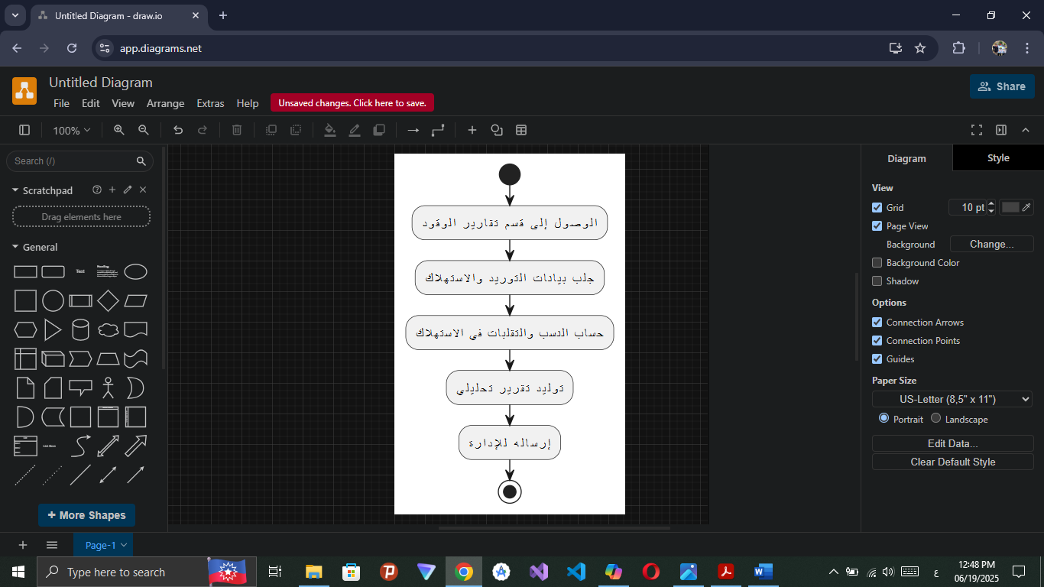

Activity Diagram of Provide Recommendations to Improve Fuel Efficiency and Reduce Costs:

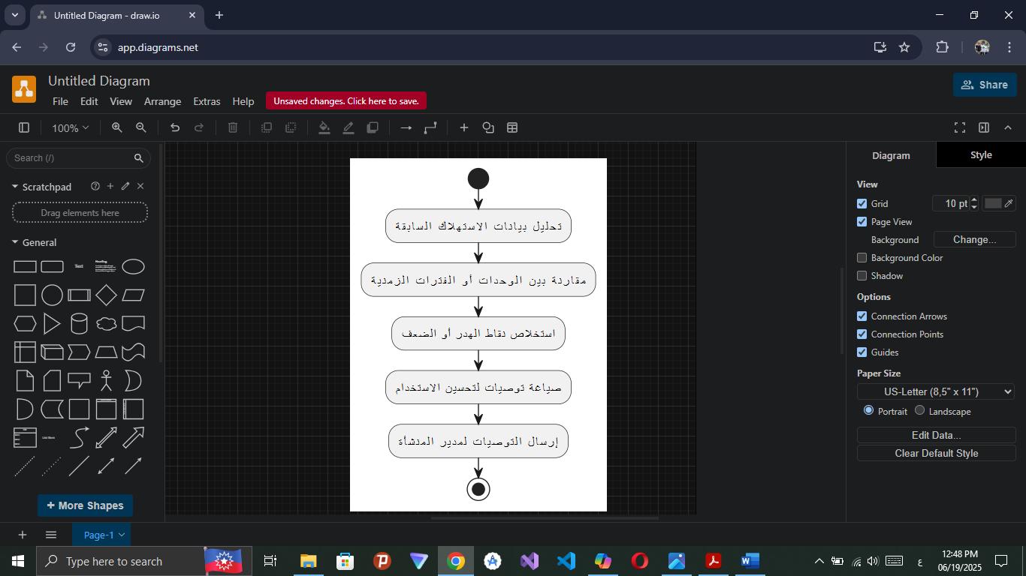

Activity Diagram of Editing , Deleting And Display of Fuel Reports:

Table of Actors and Use Cases:
Use cases | Subject
Manage user data (add/modify/delete) - Modify system settings such as work units or partitions - Monitor activity logs to keep up with the use or system | Admin System
Create production and profit reports based on available data - Plan and schedule resources (e.g. food and fuel - Send new orders to merchants - Analyze performance data to identify opportunities for improvement and make strategic decisions  order food instead of food supplier  order medicines instead of Vet  order tools instead of tools suppliers  hire a new employee  send recommendations for improving activity reports  send recommendations for improving productivity  send recommendations for improving consuming resource of facility | Facility Manager
Recording daily poultry feed data - Reporting abnormalities through simple forms - Updating the cleanliness status of the facility - Assisting in sorting and packing processes when preparing poultry for sale  Display and print packing processes  Display and print suppliers and doctor reports  Edit suppliers and doctor reports | Employee
Recording veterinary examinations for individual and group cases - Follow-up of prevention and treatment plans - Providing recommendations to improve the health environment within the facility  Send feeding plans to insure health of poultry  Display and print reports | Veterinarian
Adding details of supplied food items (quantity and quality) - Providing direct quotes through the system - Updating the status of previous orders (delivered/not delivered) - Providing reports on food consumption to determine future quantities required  Edit and delete pricing offers  Edit, display and print cosuming food reports | Food Supplier
Record the amount of fuel supplied in each process - Report any delivery issues - Provide periodic reports on fuel consumption - Make recommendations to improve fuel efficiency and reduce costs  Send reports about consuming fuel  Edit, display and print cosuming fuel reports | Fuel Supplier

Use Case Diagram:
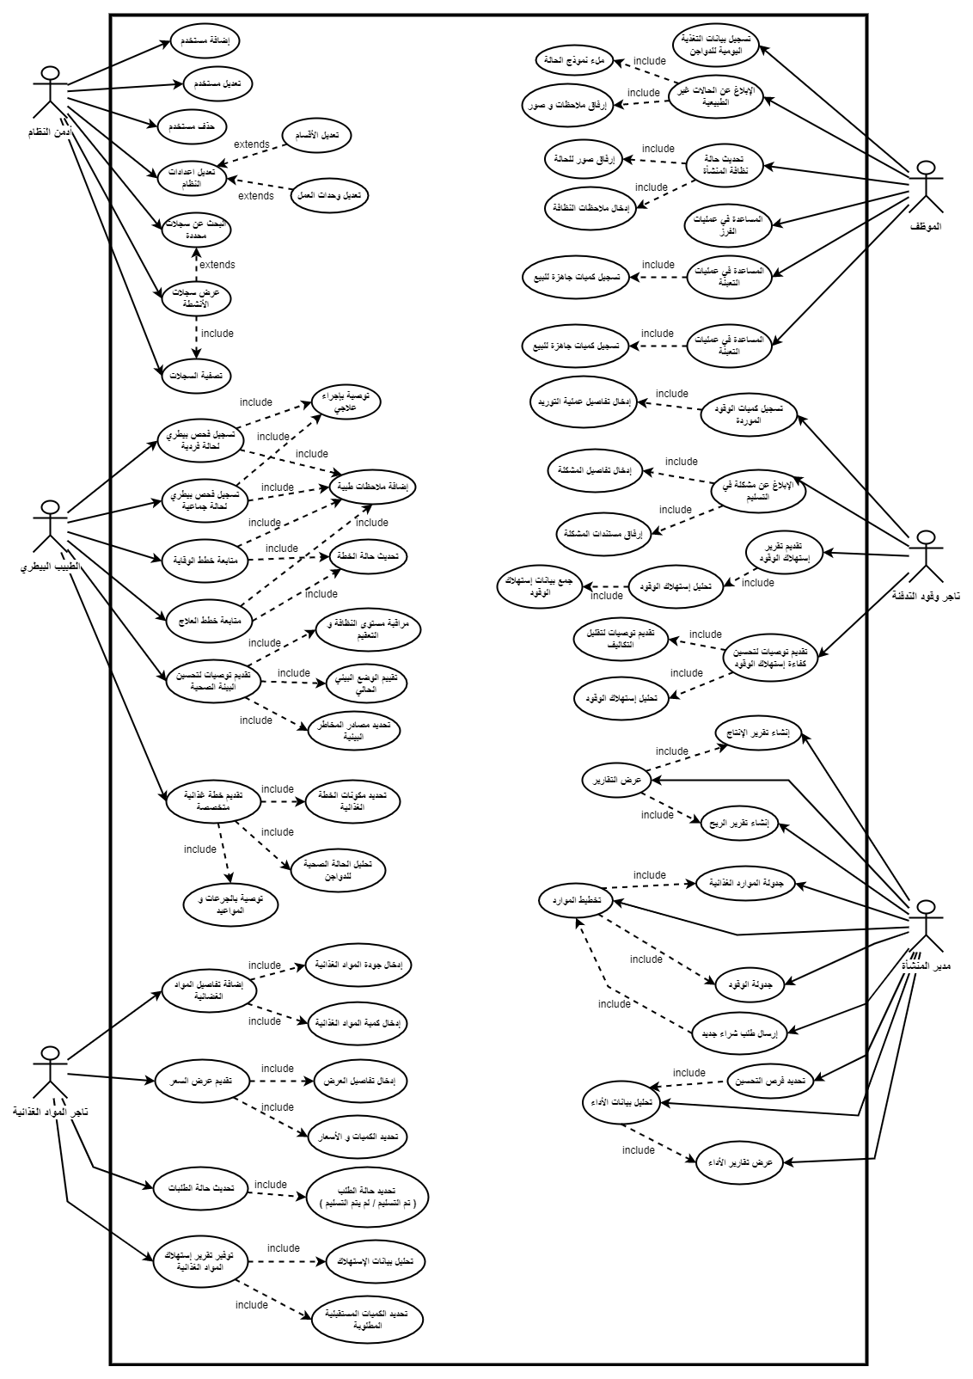

Textual Description of Use Cases:

Use Case Diagram for System Admin:
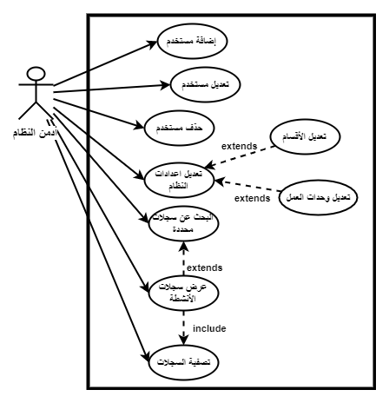

1: Use Case Description of User Data Management
Text Description of system admin use cases:
Uc-1 | Requirement ID
Manage user data (add/modify/delete) | Description:
Admin System | Actors:
The user must be registered with the system as an admin.  The admin must have successfully logged in to the system.  The admin must have the authority to manage the users. | Prerequisites:
The user database is updated in accordance with the process performed (add, modify, delete).  A pass/fail message is displayed for the process.  The process is recorded in the activity logs (logs) for tracking purposes. | Subsequent Conditions:
The admin logs in to the system  From the main menu, select "Manage Users"  The system displays a list of all existing users  The admin chooses one of the following options (Add , Delete , Edit )  The admin chooses the user who wants to manage their data  Adds, modifies, or deletes as he wants | Main Flow:

Uc-2 | Requirement ID
Modify system settings such as (work units/departments) | Description:
Admin System | Actors:
The user must be registered with the system as an admin.  The admin must have successfully logged in to the system.  The system must be connected to the database.  The admin has access to the system settings. | Prerequisites:
New edits are saved in the database.  System settings are updated immediately or upon reboot (depending on the nature of the system).  Amendments are recorded in the system logs for tracking purposes.  Notify the admin of the success or failure of the process. | Subsequent  Conditions:
- The admin logs in to the system.  - From the main menu, select System Settings.  - Current settings (e.g. sections, work units...) are displayed.  - The admin chooses what he wants to modify: (Modify the name of a department or unit - add a new section - delete an unused section).  - It makes the required adjustments.  - Press Save.  - The system validates the entered data.  - If the data is correct:  - They are saved in the database.  - A notification appears that the operation has been successful.  - Changes are logged in the system log. | Main Flow:

Uc-3 | Requirement ID
Monitor activity logs to keep track of system usage | Description:
Admin System | Actors:
The admin must have logged in to the system successfully.  Activity logs must be saved in the system (continuously or periodically).  The admin must have access to the "Activity Logs" page. | Prerequisites:
The admin can view the activities that have taken place within the system (login, modify data, delete, add... etc.).  No data in the system is modified by the rendering process.  It is recorded that the admin has viewed the logs (for security purposes, if necessary). | Subsequent  Conditions:
The admin logs in to the system.  From the main menu, select "Activity Logs"  The system displays a list of records in chronological order (most recent first),  including:  Username.  Type of operation (add, delete, modify, enter...).  Time and date.  IP address if available.  Administrators can use filters to sort records:  By date.  Depending on the user.  Depending on the type of operation.  The admin browses the logs as needed.  Details are displayed without any modification to the records | Main Flow:
3: Use Case Description of monitoring activity logs to follow up on system usage

Use Case Diagram for Facility Manager:
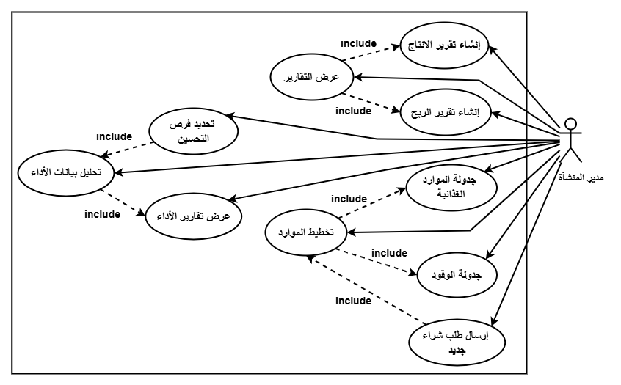

1: Use Case Description of User Data Management (Add/Modify/Delete)
Textual Description of Facility Manager Use Cases:
M-1 | Requirement ID
User Data Management (Add/Modify/Delete) | Description:
Facility Manager | Actors:
The user must be registered as a facility manager.  The administrator must have successfully logged in to the system.  Production, sales and cost data must be stored and updated in the system (e.g., number of birds, feed quantities, expenses, sales...).  The system must have the ability to extract and analyze data. | Prerequisites:
A detailed report was created that included production and profitability in a given period.  The report is saved in the system or exported (PDF/Excel).  The manager can review or print the report.  The report creation process is recorded in the activity log. | Subsequent Conditions:
- The manager logs in to the system.  - From the menu, select Reports.  - Specifies the type of report: (Production Report/Profit Report).  - Specifies the required time period (e.g., March 1 to March 31).  - Tap "Create Report".  - The system collects and analyzes data from:  - Production quantities (number of birds, eggs, weight...).  - Costs (feed, medicines, labor...).  - Returns (sales).  - The system calculates the required indicators:  - Total production.  - Total costs.  - Profit or loss.  - The report is displayed on the screen | Main Flow:

M-2 | Requirement ID
Generate production and profit reports based on available data | Description:
Facility Manager | Actors:
- The user must be registered as an "admin".  - The admin must have logged in to the system successfully.  - Activity logs must be saved in the system (continuously or periodically).  - The admin must have access to the "Activity logs" page | Prerequisites:
- The admin can view the activities that have taken place within the system (login, modify data, delete, add... etc.).  - No data in the system is modified by the rendering process.  - It is recorded that the admin has viewed the logs (for security purposes, if necessary). | Subsequent Conditions:
- The admin logs in to the system.  - From the main menu, select "Activity Logs."  - The system displays a list of records in chronological order (most recent first), including:  - Username.  - Type of operation (add, delete, modify, enter...).  - Time and date.  - IP address if available.  - Administrators can use filters to sort records:  - By date.  - Depending on the user.  - Depending on the type of operation.  - The admin browses the logs as needed.  - Details are displayed without any modification to the records | Main Flow:

M-3 | Requirement ID
Planning and scheduling resources (e.g., food and fuel) | Description:
Facility Manager | Actors:
Such as food (poultry feed) and fuel.  The system must be up-to-date with supplier information and the ability to add or modify suppliers.  Estimates of poultry food and fuel needs based on the number and age stages of poultry.  Such as the number of poultry, the area of the barns, and other details related to the agricultural environment.  There should be a start date for the chart or timeline for each operation (such as the start date of the day or the specified period of supply). | Prerequisites:
Food and fuel scheduling should be done based on actual need.  The database must be modified to update the available amounts of resources and scheduling dates.  The facility manager should receive a notification when resources are running out or when new payments need to be received.  A report on food and fuel consumption should be generated and aligned with expectations.  Poultry food and fuel needs in the future should be determined based on current consumption | Subsequent Conditions:
- The facility manager enters the poultry data such as ( the number of poultry, barns, and their daily needs of food and fuel).  - The system calculates the amount of food and fuel required based on the number of poultry and its needs.  - The system creates a plan to schedule supplies of food and fuel according to the calculated needs.  - Supplier details such as (supply time and material prices) are entered.  - A notification will be sent to the facility manager of the date of receipt of the required materials or supplies.  - The system provides periodic reports to the facility manager on ( the amount of resources consumed, suppliers and delivery dates). | Main Flow:
M-4 | Requirement ID
Send new orders to merchants | Description
Facility Manager | Actors
The system should have up-to-date information about the suppliers and merchants to whom orders can be sent.  There must be a warehouse or database that contains information on the available inventory in the facility (e.g., food, feed, fuel, etc.).  Accurate details of the facility's needs for the materials you wish to purchase (e.g. quantities ordered, type of materials, delivery dates) must be entered.  The facility manager must have the necessary powers to send purchase orders, whether through the system or the merchant communication mechanism.  There must be a approved budget for procurement so that orders can be executed within the available budget. | Prerequisites:
- Food and fuel scheduling should be done based on actual need.  - The database must be modified to update the available amounts of resources and scheduling dates.  - The facility manager should receive a notification when resources are running out or when new payments need to be received.  - A report on food and fuel consumption should be generated and aligned with expectations.  - Poultry needs for food and fuel in the future should be determined based on current consumption. | Subsequent Conditions
- The facility manager enters poultry data, such as the number of poultry, barns, and their daily food and fuel needs.  - The system calculates the amount of food and fuel required based on the number of poultry and its needs.  - The system creates a plan to schedule supplies of food and fuel according to the calculated needs.  - Supplier details are entered, such as supply time and material prices.  - A notification will be sent to the facility manager of the date of receipt of the required materials or supplies.  - The system provides periodic reports to the facility manager on the amount of resources consumed, suppliers and delivery dates | Main Flow

Requirement ID | M-5
Description | Request Feed from Food Supplier
Actors | Manager
Preconditions | 1. Manager is logged in and authorized.  2. Current feed inventory is recorded.  3. Minimum stock level is defined.
Postconditions | 1. New purchase order created with status "Pending Send".  2. Order history updated.  3. Inventory updated after supplier confirmation
Main Flow | 1. Manager selects "New Feed Request".  2. System shows recommended quantity.  3. Manager enters quantity and selects supplier.  4. System generates order invoice.  5. Manager clicks "Send Order".  6. System sends order to supplier.  7. Confirmation shown and order logged.
Alternative Flow | Send fails → Save as draft with retry option.

Requirement ID | M-6
Description | Order Medicines from Vet
Actors | Manager
Preconditions | 1. Manager is logged in and authorized.  2. Current medicine inventory is recorded.  3. Minimum stock level is defined or manager  4. List of available medicines and Vet suppliers is maintained in the system.
Postconditions | 1. New medicine purchase order created with status "Pending Send".  2. Order history updated.  3. Inventory updated after Vet confirmation.  4. Notification sent to manager upon order confirmation.
Main Flow | 1. Manager selects "Medicine Management" → "New Medicine Order".  2. System displays current medicine stock and recommended reorder quantities.  3. Manager selects required medicines (type, quantity, dosage form if applicable).  4. Manager selects the Vet (supplier) from the list. 5. System generates an order summary with: medicine names, quantities, unit prices, total cost, requested delivery date.  6. Manager reviews and clicks "Send Order".  7. System sends the order to the Vet (via API, email, or dedicated interface)  8. System shows confirmation "Order sent successfully" and logs the request with timestamp.  9. System updates expected delivery status
Alternative Flow | Send fails → Save as draft with retry option.

Requirement ID | M-7
Description | Manage Order Tools from Tool Supplier
Actors | Manager
Preconditions | 1- Manager is logged in.  2- Tool inventory is recorded.
Postconditions | Order is saved and sent to supplier.
Main Flow | 1. Manager clicks "Order Tools".  2. System shows list of tools.  3. Manager selects tool and enters quantity.  4. Manager clicks "Submit Order".  5. System sends order to supplier.  6. System shows "Order sent".
Alternative Flow | Send fails → Save as draft with retry option.

Requirement ID | M-8
Description | Hire New Employee
Actors | Manager
Preconditions | 1- Manager is logged in.
Postconditions | 1- New employee is added to the system.
Main Flow | 1. Manager clicks "Add Employee".  2. Manager enters employee details (name, position).  3. Manager clicks "Save".  4. System saves employee and shows "Employee added successfully".
Alternative Flow | If employee email or phone already exists: System shows "Employee already exists" and asks to use different details.

Requirement ID | M-9
Description | Send Recommendations for Improving Activity Records
Actors | Manager
Preconditions | 1- Manager is logged in.  2- Activity records exist in the system
Postconditions | 1- Recommendation is saved and sent.
Main Flow | 1. Manager clicks "Send Recommendations".  2. Manager writes recommendation text.  3. Manager clicks "Submit".  4. System saves and sends recommendation.  5. System shows "Recommendation sent successfully".
Alternative Flow | If recommendation text is empty:  System shows "Please enter recommendation text" and asks manager to write something.

Requirement ID | M-10
Description | Send Recommendations for Improving Productivity
Actors | Manager
Preconditions | 1- Manager is logged in.  2- Productivity data (food quantity, egg count) is available.
Postconditions | 1- Recommendation is saved and sent.
Main Flow | 1. Manager clicks "Send Productivity Recommendations".  2. Manager selects type (Food Quantity or Egg Count).  3. Manager writes recommendation text.  4. Manager clicks "Submit".  5. System saves and sends recommendation.  6. System shows "Recommendation sent successfully".
Alternative Flow | If recommendation text is empty: System shows "Please enter recommendation  text" and asks manager to write something.

Requirement ID | M-11
Description | Send Recommendations for Improving Consuming Resources
Actors | Manager
Preconditions | Manager is logged in. Resource consumption data is available.
Postconditions | Recommendation is saved and sent.
Main Flow | 1. Manager clicks "Send Resource Recommendations".  2. Manager writes recommendation text.  3. Manager clicks "Submit".  4. System saves and sends recommendation.  5. System shows "Recommendation sent successfully".
Alternative Flow | If recommendation text is empty: System shows "Please enter recommendation  text" and asks manager to write something.

M-12 | Requirement ID
Analyze performance data to identify opportunities for improvement and make strategic decisions | Description
Facility Manager | Actors
The system must contain accurate and up-to-date data on the performance of the facility, such as:  - Poultry growth rates.  - Feed consumption.  - Production rates (e.g. eggs or meat).  - Operational costs (e.g., food, labor, fuel, etc.)  - Data on losses or diseases.  The key performance indicators to be analyzed such as production rates, costs, returns, losses, etc. should be identified.  There should be pre-defined criteria or targets (such as monthly or annual targets) to compare actual performance.  The manager must have the necessary tools in the system to view and analyze the data, such as graphs, interactive tables, and analytical reports.  The facility manager must have the appropriate authority to access and analyze this data. | Prerequisites
- A report with a comprehensive performance analysis should be created based on the data entered, identifying areas that need improvement.  - Potential opportunities to improve processes or increase efficiency, whether in resource consumption or production optimization, should be identified.  - Based on the analysis, strategic decisions are made such as:  - A change in production practices.  - Edit the resource scheduling.  - Improve procurement or supply strategies.  - Future action plans are adjusted based on the findings from the analysis.  - A brief report or notice must be sent to the parties involved (such as managers or operational teams) to implement the new changes or strategies. | Subsequent Conditions

Use Case Diagram for Veterinarian:

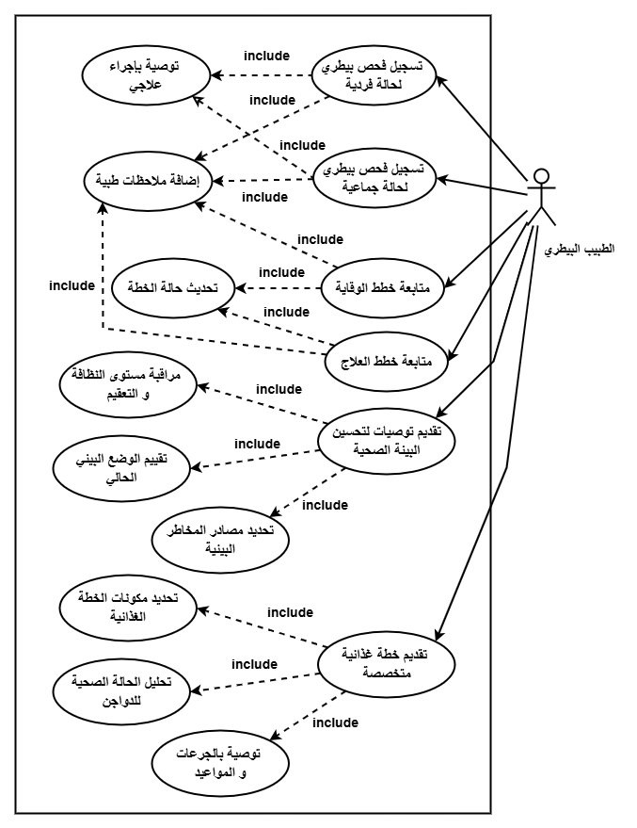

Textual Description of Veterinarian Use Cases:
Requirement ID | AB-1
Description | Recording veterinary examinations for individual and group cases
Actors | Veterinarian
Pre-conditions | The veterinarian must have an active account with permission to enter and modify examination data.  Poultry data (groups or individuals) must be pre-registered in the system with identification codes.  The system must contain a form for entering veterinary examination data for both individual and group cases.  The system must support distinguishing between group cases (e.g., an entire flock) and individual cases (a single bird or small group).  There must be an updatable list of common diseases or symptoms to facilitate accurate diagnosis entry by the veterinarian.
Post-conditions | - All examination details are saved in the database for future reference.  - The examination is automatically linked to the case or flock in their health record.  - If a contagious disease is detected, the system issues an alert to the facility manager or relevant teams.  - A medical report for the individual or group case can be generated, including symptoms, examination findings, recommended treatment, and follow-up date.  - Based on the type of disease, the system can suggest a treatment plan and schedule for follow-up visits.
Main Flow: | 1. Determine whether the case is individual (bird/small group) or collective (entire flock).  2. Select the sick poultry via an identification number or group name.  3. Enter examination details:  - Date and time  - Observed symptoms  - Tests performed  - Clinical observations  4. Select the disease or suspected condition from a list or enter it manually.  5. Prescribe medications, isolation, or any preventive or therapeutic measures.  6. Save the data in the system and update the medical record for the bird or flock.  - 7. Send a notification to the manager or health supervisor in case of a critical or communicable condition.

Requirement ID | AB-2
Description | Monitoring prevention and treatment plans
Actors | Veterinarian
Pre-conditions | - The veterinarian must be registered in the system with access permissions.  - There must be barns registered in the system.  - There must be a pre-recorded treatment or prevention plan (either prepared by the veterinarian or the barn supervisor).  - Availability of vital and health data for poultry (temperature, weight, symptoms, etc.).
Post-conditions | - A new follow-up for the flock's health condition has been recorded.  - The prevention or treatment plan has been updated (if necessary).  - Relevant parties have been notified of changes (e.g., field workers, barn supervisor).  - A time-stamped record of modifications has been maintained for tracking and future review.
Main Flow | 1. The veterinarian logs into the system.  2. Navigates to the "Prevention and Treatment Plans" section.  3. Selects the barn or flock to follow up on.  4. Reviews the approved prevention or treatment plan.  5. Updates the poultry health status based on daily or periodic examinations.  6. Adds medical notes or instructions (e.g., changing treatment, adjusting dosage, suggesting additional tests).  7. Saves the modifications in the system.  8. Modifications are recorded and notifications are sent to supervisors or relevant workers (if required).
Alternative Flow | - No treatment plan recorded yet: The veterinarian adds a new plan before proceeding.  - Flock data not updated: A warning message appears for the veterinarian, who can request the supervisor to update the data or do it themselves.  - Veterinarian not authorized to access a specific barn: An access denial notification appears, prompting a request to the administrator to modify permissions.

Requirement ID | AB-3
Description | Providing recommendations to improve the health environment within the facility
Actors | Veterinarian
Pre-conditions | - The facility manager has an account and access permission to the system.  - Environmental and health data are recorded in the system (e.g., air quality, humidity, ventilation, temperature, barn cleanliness, recorded health conditions).  - Periodic or real-time reports from various departments are available (e.g., veterinarian reports, supervisor reports, environmental sensor system if available).
Post-conditions | - New environmental recommendations have been recorded, linked to a specific date and barn or department.  - Relevant teams have been notified of the required recommendations for implementation.  - The recommendations are now part of the environmental improvement record and can be tracked later.  - The recommendations can be used in performance reports or facility quality reviews.
Main Flow | 1. The facility manager logs into the system.  2. Navigates to the "Environmental Recommendations" section.  3. Reviews the health and environmental data for the barns or various departments in the facility.  4. Analyzes the indicators or relies on system-generated reports.  5. Identifies areas needing improvement (e.g., ventilation, cleanliness, lighting, etc.).  6. Enters the appropriate recommendations in the system (manually or using ready-made templates).  7. Saves the recommendations, which are then sent to the relevant parties (supervisors, technicians, veterinarian, etc.).  8. The recommendations are recorded as a reference log.
Alternative Flow: | - No updated environmental data: The system displays a warning and asks the manager to request data updates from the relevant team or wait.  - Manager requests an automated analytical report: The system generates preliminary recommendations based on recorded data (if smart analysis or AI technology is available in the system).  - Sent recommendations require approval: Recommendations are saved in a "pending" status and sent to the authorized party for review and approval (e.g., veterinarian or a small administrative board within the system).

Requirement ID | AB-4
Description | Providing specialized dietary plans to ensure the health and proper growth of poultry
Actors | Veterinarian
Pre-conditions | The facility manager must be registered and authenticated in the system.  Poultry data (age, species, health condition, production goal) must be recorded in the system.  A database containing nutritional values and feed components must be available.
Post-conditions | A specialized dietary plan is created based on specified criteria.  The plan is saved within the relevant flock's record.  The plan can be printed or shared with field or farm personnel.
Main Flow | 1. The facility manager logs into the system.  2. Selects "Dietary Plan Management".  3. Specifies the target flock (or a specific poultry group).  4. Defines the following criteria:  - Type (layer / broiler)  - Age stage  - Goal (growth / fattening / egg production)  - Special environmental or health conditions if any  5. Clicks "Generate Dietary Plan".  6. The system analyzes the data and generates an appropriate dietary plan.  7. The system displays the proposed dietary plan in detail.  8. The manager can approve, modify, or export the plan.
Alternative Flow | - Alternative 1 – Flock data not available: If flock data is unavailable, the system displays a warning and requests it be entered first.  - Alternative 2 – Incompatible input criteria: If the manager enters incompatible data (e.g., an age that does not match the plan type), the system displays an error message requesting correction.  - Alternative 3 – Plan generation fails due to insufficient nutritional data: The system displays a warning about missing nutritional components and suggests adding them to the database or using a default plan.

Requirement ID | AB-5
Description | Vet display and print reports records
Actors | Veterinarian
Preconditions | 1- Vet is logged in.  2- Report records existing the system
Postconditions | 1- Report is displayed and/or printed.
Main Flow | 1. Vet clicks "View Reports".  2. System shows list of available reports.  3. Vet selects a report.  4. System displays the report.  5. Vet clicks "Print".  6. System sends report to printer.
Alternative Flow | If no reports exist: System shows "No reports available" message.

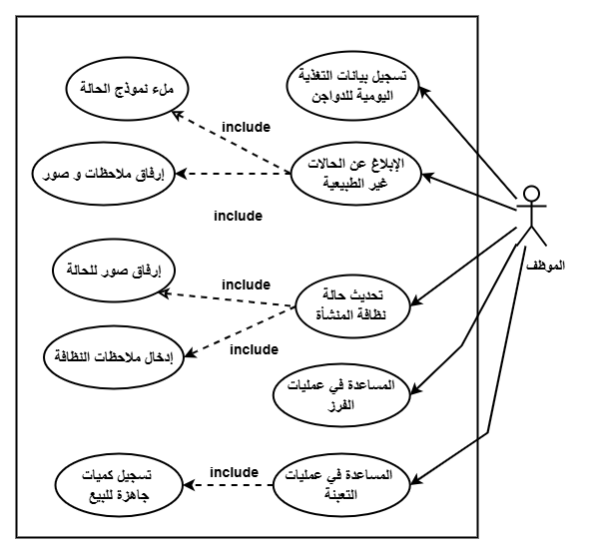

Use Case Diagram for Employee:

Textual Description of Employee Use Cases:
Requirement ID | AC-1
Description | Recording daily feeding data for poultry
Actors | Employee
Pre-conditions | - The employee must be registered and authorized to access the system.  - There must be a specified and approved feeding plan for each flock.  - The flock or barn for which data will be recorded must be identified.
Post-conditions | - Daily feeding data is saved in the system database.  - Data becomes available for reports or analysis by the manager or veterinarian.  - Data can be used to monitor compliance with the dietary plan and analyze performance.
Main Flow | 1. The employee logs into the system.  2. Selects "Record Daily Feeding" from the menu.  3. Specifies the target flock or barn.  4. Enters the following data:  - Date  - Type of feed provided  - Quantity (kg or ton)  - Number of meals or distribution times  - Notes (if any, e.g., feed rejection, distribution issues)  5. Reviews the entries and clicks "Save".  6. The system confirms successful recording and displays a confirmation message.
Alternative Flow | - Alternative 1 – No flock selected: The system displays a message: "Please select a flock first," and returns the user to the appropriate step.  - Alternative 2 – Incomplete or incorrect data: If the quantity or type is not entered, the system displays a warning and requests data completion.  - Alternative 3 – Feeding plan not available: The system displays a warning that the specified flock has no registered feeding plan and prevents recording until it is set up by the manager.

Requirement ID | AC-2
Description | Reporting abnormal conditions via simple forms
Actors | Employee
Pre-conditions | - The employee must be registered in the system and have reporting permissions.  - Information about the flock or barn to be reported must exist in the system.  - An electronic reporting form must be available within the system (or mobile app) with the required fields.
Post-conditions | - The report is saved in the database as a note linked to the flock or location.  - An automatic notification is sent to the manager, veterinarian, or relevant authority.  - The report status can be tracked (processed, under action, closed).
Main Flow | 1. The employee logs into the system and selects "Abnormal Condition Report Form".  2. Specifies:  - The relevant flock or barn  - Type of condition (health, behavior, environmental, nutritional)  3. Enters condition details, such as:  - Description (e.g., sudden death, drop in feed consumption, unusual sound, high temperature)  - Date and time  - Photos or video (optional – if supported)  4. Clicks "Submit Report".  5. The system displays a confirmation message and generates a report tracking number.
Alternative Flow | - Alternative 1 – No flock or barn selected: The system displays a warning: "Please select a flock or barn first," and prevents submission.  - Alternative 2 – Incomplete data: If the description field is left empty, the system displays an error message and requires it to be filled before proceeding.  - Alternative 3 – Connection or save failure: The system displays an error message: "Unable to submit report. Check connection or try again later," and temporarily stores the report in offline mode (if supported).

Requirement ID | AC-3
Description | Updating the cleanliness status of the facility
Actors | Employee
Pre-conditions | - The employee is registered in the system.  - The employee has successfully logged in.
Post-conditions | - The new cleanliness status has been saved successfully.  It is now available for management and review.
Main Flow | 1. The employee logs into the system.  2. Navigates to the "Cleanliness Status" section.  3. Selects the relevant facility or department.  4. Specifies the status (Clean, Needs Cleaning, Cleaning in Progress, etc.).  5. Adds notes if applicable.  6. Clicks "Save".  7. The system displays a success message.
Alternative Flow | - Employee not registered / not authorized: A message appears: "You do not have permission."  - Network connection unavailable: A message appears: "Connection failed, please try again later."  - Incomplete or incorrect input: A warning appears to correct the required data.

Requirement ID | AC-4
Description | Assisting in sorting operations
Actors | Employee
Pre-conditions | - The employee is registered in the system.  - The employee has successfully logged in.
Post-conditions | - The employee's participation in the sorting operation has been recorded.  - Data is available for management and reports.
Main Flow | 1. The employee logs into the system.  2. Navigates to the "Sorting Operations" section.  3. Selects the sorting type (by age, weight, health condition, etc.).  4. Specifies the time or quantity contributed.  5. Adds notes when needed.  6. Clicks "Save".  7. A confirmation notification appears confirming the operation is complete.
Alternative Flow | - Employee not logged in: Redirected to the login screen.  - Sorting type not specified or data incomplete: A message appears: "Please complete all required fields."  - Connection or server error: A message appears: "An error occurred, please try again later."

Requirement ID | AC-6
Description | Display and Print Sorting and Packing Processes
Actors | Employee
Preconditions | 1- Employee is logged in.  2- Sorting and packing records exist.
Postconditions | Processes are displayed and/or printed.
Main Flow | 1. Employee clicks "View Sorting & Packing".  2. System shows list of sorting/packing tasks.  3. Employee selects a task.  4. System displays task details.  5. Employee clicks "Print".  6. System sends task details to printer.
Alternative Flow | If no tasks exist: System shows "No sorting or packing tasks available".

Requirement ID | AC-5
Description | Assisting in packaging operations
Actors | Employee
Pre-conditions | The employee is registered in the system.  The employee has successfully logged in.
Post-conditions | The employee's contribution to packaging has been recorded.  Data has been added to work and production reports.
Main Flow | 1. The employee logs into the system.  2. Navigates to the "Packaging Operations" section.  3. Specifies the type of packaging (eggs, poultry, feed, etc.).  4. Specifies the quantity or time period worked.  5. Adds notes (optional).  6. Clicks "Save".  7. A notification of successful recording appears.
Alternative Flow | - Employee not logged in: Access is denied and login is required.  - Required data not entered: A message appears: "Please fill in all required fields."  - Data save failure due to technical issue: A warning appears: "A technical error occurred, please try again later."

Requirement ID | AC-7
Description | Display and Print Reports from Suppliers , Vet
Actors | Employee
Preconditions | - Employee is logged in.  - Reports from suppliers and vet exist.
Postconditions | Reports are displayed and/or printed
Main Flow | 1. Employee clicks "View Reports".  2. System shows report sources (Suppliers, Vet)  3. Employee selects a source.  4. System shows list of reports from that source. 5. Employee selects a report.  6. System displays the report.  7. Employee clicks "Print".  8. System sends report to printer.
Alternative Flow | If no reports exist: System shows "No reports available from this source".

Requirement ID | AC-8
Description | Edit Reports from Suppliers and Vet
Actors | Employee
Preconditions | - Employee is logged in.  - Reports from suppliers and vet exist.
Postconditions | Report is updated and saved in the system
Main Flow | 1. Employee clicks "View Reports".  2. System shows report sources (Suppliers, Vet)  3. Employee selects a source.  4. System shows list of reports.  5. Employee selects a report.  6. System displays the report.  7. Employee clicks "Edit".  8. Employee modifies report data.  9. Employee clicks "Save".  10. System saves changes and shows "Report updated successfully".
Alternative Flow | If report does not exist: System shows "Report not found" message

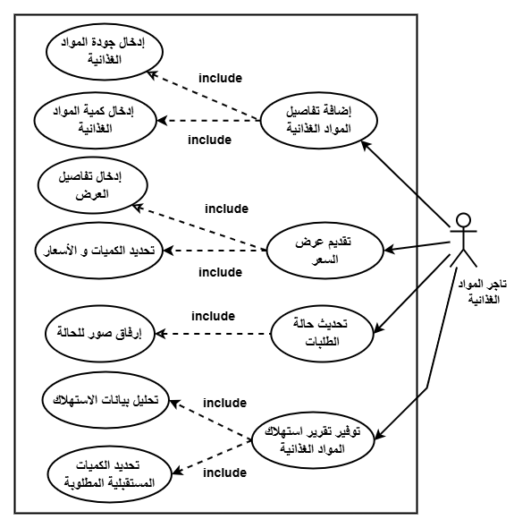
Use Case Diagram for

Food Supplier:

Textual Description of Food Supplier Use Cases:
Requirement ID | RB-1
Description | Adding food supply details
Actors | Food Supplier
Pre-conditions | - The supplier is registered in the system.  - The supplier has successfully logged in.
Post-conditions | - The supply data has been saved in the system.  - Data is available for management and monitoring.
Main Flow | 1. The supplier logs into the system.  2. Navigates to the "Food Supply" section.  3. Specifies the type of supplied material (corn, feed, supplements, etc.).  4. Enters the supplied quantity.  5. Rates the quality (high, medium, low or according to specific standards).  6. Adds the date and any additional notes.  7. Clicks "Save".  8. The system displays a message: "Supply added successfully."
Alternative Flow | - Supplier not registered or not logged in: Redirected to the login page.  - Incomplete data entry: A message appears: "Please enter all required fields."  - Save failure due to technical error: A message appears: "An error occurred while saving, please try again later."

Requirement ID | RB-2
Description | Submitting a direct price quote
Actors | Food Supplier
Pre-conditions | - The supplier is registered in the system.  - The supplier has successfully logged in.
Post-conditions | - The price quote has been saved successfully.  - The quote is now available to management for review or evaluation.
Main Flow | 1. The supplier logs into the system.  2. Navigates to the "Price Quotes" section.  3. Clicks "Add New Quote".  4. Selects the type of food material (e.g., feed, corn, supplements).  5. Specifies the quantity covered by the quote.  6. Enters the proposed price per unit.  7. Adds the quote date and validity period.  8. Can add notes or additional conditions.  9. Clicks "Submit".  10. The system displays a message: "Price quote submitted successfully."
Alternative Flow | - Supplier not logged in: Redirected to login first.  - Incomplete or incorrect entry: A message appears: "Please complete all required fields correctly."  - Save or connection failure: A message appears: "Unable to submit quote, please try again later."

Requirement ID | RB-3
Description | Updating the order status (Delivered / Not Delivered)
Actors | Food Supplier
Pre-conditions | - The supplier is registered in the system.  - The supplier has successfully logged in.
Post-conditions | - The order status has been updated successfully.  - The new status is available to management and for monitoring.
Main Flow | 1. The supplier logs into the system.  2. Navigates to the "Previous Orders" section.  3. Reviews the list of their orders.  4. Selects the order whose status is to be updated.  5. Selects the status (Delivered / Not Delivered).  6. Can enter additional notes, such as the reason for delay.  7. Clicks "Update".  8. The system displays a confirmation message: "Order status updated successfully."
Alternative Flow | - Supplier not logged in: A warning appears and login is requested.  - No orders linked to the supplier: The system displays a message: "No orders to display."  - Update failure due to technical error: A message appears: "Unable to update status, please try again later."

Requirement ID | RB-5
Description | Providing a food consumption report
Actors | Food Supplier
Pre-conditions | - The supplier is registered in the system.  - The supplier has successfully logged in.
Post-conditions | - The report has been sent to management.  - It is now available in the reports and analytics database.
Main Flow | 1. The supplier logs into the system.  2. Navigates to the "Consumption Reports" section.  3. Selects the time period (e.g., month, quarter).  4. Enters consumption details (material type, quantity consumed, quality notes).  5. Clicks "Submit Report".  6. The system displays a message: "Report submitted successfully."
Alternative Flow | - Supplier not logged in: A warning appears: "Please log in first."  - Incomplete detail entry: A message appears: "Please complete all required fields. "Technical failure during submission: A message appears: "An error occurred during submission, please try again later."
Requirement ID | RB-4
Description | Edit and Delete Pricing Offers
Actors | Food Supplier
Preconditions | - Food supplier is logged in.  - Pricing offer exists in the system
Postconditions | - Offer is updated or deleted from the system.
Main Flow | 1. Food supplier clicks "My Offers".  2. System shows list of pricing offers.  3. Supplier selects an offer.  4. Supplier clicks "Edit" or "Delete".  5. If Edit: Supplier modifies price or details and clicks "Save". System shows "Offer updated".  6. If Delete: System shows "Offer deleted".
Alternative Flow | If offer does not exist: System shows "No offers found".

Requirement ID | RB-6
Description | Send Recommendations About Food Consumption to Determine Future Quantity
Actors | Food Supplier
Preconditions | 1- Food supplier is logged in.  2- Food consumption data is available
Postconditions | Recommendation saved and sent to manager.
Main Flow | 1. Food supplier clicks "Send Food Consumption Recommendations".  2. System shows current consumption data and trends.  3. Food supplier writes recommendation for future quantity.  4. Food supplier clicks "Submit".  5. System saves and sends recommendation to manager.  6. System shows "Recommendation sent successfully".
Alternative Flow | If recommendation text is empty: System shows "Please enter recommendation text"
Requirement ID | RB-7
Description | Edit, Delete, and Print Food Consuming Reports
Actors | Food Supplier
Preconditions | 1- Food supplier is logged in.  2- Food consuming reports exist
Postconditions | 1- Reports are updated, deleted, or printed as requested.
Main Flow | 1. Food supplier clicks "Food Consuming Report  2. System shows list of reports.  3. Supplier selects a report.  4. Supplier chooses action: Edit, Delete, or Print. 5. If Edit: Supplier modifies data and clicks "Save". System shows "Report updated".  6. If Delete: System shows "Report deleted".  7. If Print: System sends report to printer.
Alternative Flow | If no reports exist: System shows "No reports found".

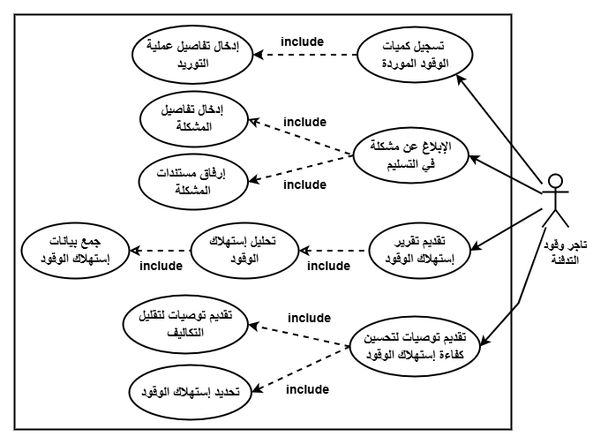
Use Case Diagram for Fuel Supplier:

Textual Description of Fuel Supplier Use Cases:

Code | FS-1
Description | Recording the quantity of fuel supplied in each operation.
Actors | Fuel Supplier
Pre-conditions | - The supplier is registered in the system.  - The supplier has successfully logged in.
Post-conditions | - The supplied fuel quantity has been recorded successfully.  - Data is available for management and monitoring.
Main Flow | 1. The supplier logs into the system.  2. Navigates to the "Fuel Supply" section.  3. Clicks "Add Supply Operation".  4. Enters the fuel type (solar, diesel, etc.).  5. Enters the supplied quantity (in liters or tons).  6. Specifies the supply date and receiving farm.  7. Adds notes if applicable.  8. Clicks "Save".  9. The system displays a message: "Supply recorded successfully."
Alternative Flow | - Supplier not logged in: A warning appears: "You must log in first."  - Quantity or required data not entered: A message appears: "Please fill in all mandatory fields."  - Save failure due to technical issue: A message appears: "An error occurred while saving, please try again later."

Code | FS-2
Description | Reporting any delivery problem.
Actors | Fuel Supplier
Pre-conditions | - The supplier is registered in the system.  - Logged in successfully.  - A previously registered delivery operation exists.
Post-conditions | - The report has been recorded in the system.  - It is now visible to facility management for review and action.
Main Flow | 1. The supplier logs into the system.  2. Navigates to the "Reports / Deliveries" section.  3. Selects the delivery operation with the issue.  4. Clicks "Report a Problem".  5. Specifies the type of problem (e.g., delay, quantity shortage, vehicle issue, etc.).  6. Enters a detailed description of the problem.  7. Attaches photos/documents if available.  8. Clicks "Submit Report".  9. The system displays a message: "Report submitted successfully."
Alternative Flow | - Not logged in: The supplier is redirected to the login page.  - Required fields not filled: A message appears: "Please fill in all required fields."  - Technical failure during submission: A message appears: "An error occurred during submission, please try again later."

Code | FS-3
Description | Submitting periodic reports on fuel consumption.
Actors | Fuel Supplier
Pre-conditions | - The supplier is registered in the system.  - Logged in successfully.  - Previous supply operations linked to the supplier exist.
Post-conditions | - The report has been saved in the system.  - It is now available to management for analysis and planning purposes.
Main Flow | 1. The supplier logs into the system.  2. Navigates to the "Fuel Consumption Reports" section.  3. Clicks "Add New Report".  4. Specifies the time period (weekly, monthly, quarterly).  5. Enters fuel quantities consumed by period or by farm.  6. Adds notes (e.g., observations on efficiency or future needs).  7. Clicks "Submit Report".  8. The system displays a message: "Report submitted successfully."
Alternative Flow | - Supplier not logged in: Login is required.  - Not all required data entered: A message appears: "Please complete all required fields."  - Report submission failure: A message appears: "An error occurred during submission, please try again later."

Requirement ID | FS-5
Requirement Name | Provide Reports About Fuel Consumption
Actors | Fuel Supplier
Preconditions | 1- Fuel supplier is logged in.  2- Fuel consumption data is available.
Postconditions | Report is saved and visible to manager.
Main Flow | 1. Fuel supplier clicks "Provide Fuel Report".  2. System shows fuel consumption data.  3. Fuel supplier enters report details  4. Fuel supplier clicks "Submit".  5. System saves the report.  6. System shows "Report provided successfully".
Alternative Flow | If fuel consumption data is missing: System shows "No consumption data available".
Code | FS-4
Description | Providing recommendations to improve fuel consumption efficiency and reduce costs.
Actors | Fuel Supplier
Pre-conditions | - The supplier is registered in the system.  - Logged in successfully.  - Previous supply operations linked to the supplier exist.
Post-conditions | - The recommendations have been saved in the system.  - They are now visible to management for consideration and action.
Main Flow | 1. The supplier logs into the system.  2. Navigates to the "Recommendations" section.  3. Clicks "Add New Recommendation".  4. Writes the recommendation text (e.g., using specific fuel types, improving thermal insulation, energy-saving technologies, etc.).  5. Attaches supporting files if available (photos, reports, PDF documents).  6. Clicks "Submit Recommendation".  7. The system displays a message: "Recommendation submitted successfully."
Alternative Flow | - Not logged in: A warning appears: "You must log in to submit a recommendation."  - Recommendation incomplete or fields empty: A warning appears: "Please enter the recommendation text at least."  - Submission failure due to system malfunction: A message appears: "Unable to submit recommendation, please try again later."

Requirement ID | FS-6
Requirement Name | Edit, Delete, and Print Fuel Consumption Report
Actors | Fuel Supplier
Preconditions | 1- Fuel supplier is logged in.  2- Fuel consumption reports exist.
Postconditions | 1- Reports are updated, deleted, or printed as requested.
Main Flow | 1. Fuel supplier clicks "Fuel Consumption Reports".  2. System shows list of reports.  3. Supplier selects a report.  4. Supplier chooses action: Edit, Delete, or Print. 5. If Edit: Supplier modifies data and clicks "Save". System shows "Report updated".  6. If Delete: System asks "Are you sure?" Supplier clicks "Yes". System shows "Report deleted".  7. If Print: System sends report to printer.
Alternative Flow | If no reports exist: System shows "No reports found".

Sequence Diagram:

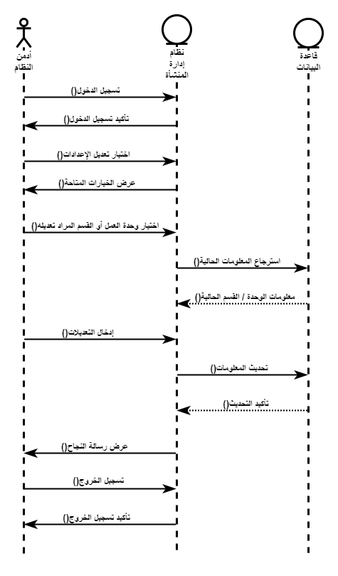

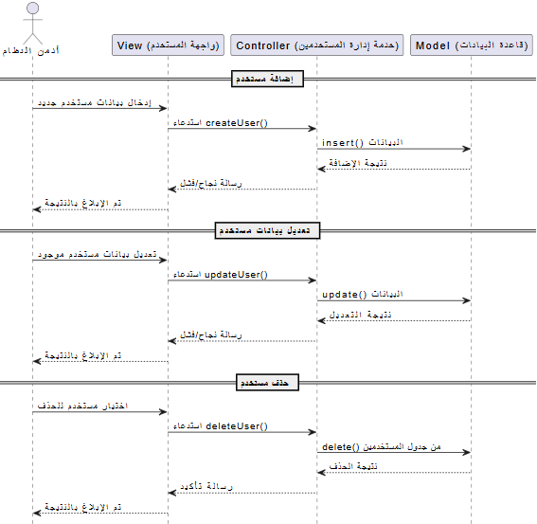
User data management(Add-delete-edit)

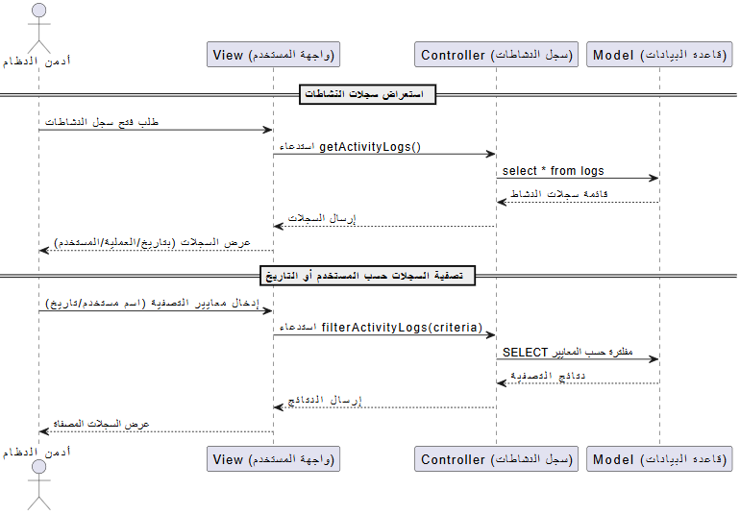
activity logs to track system usage

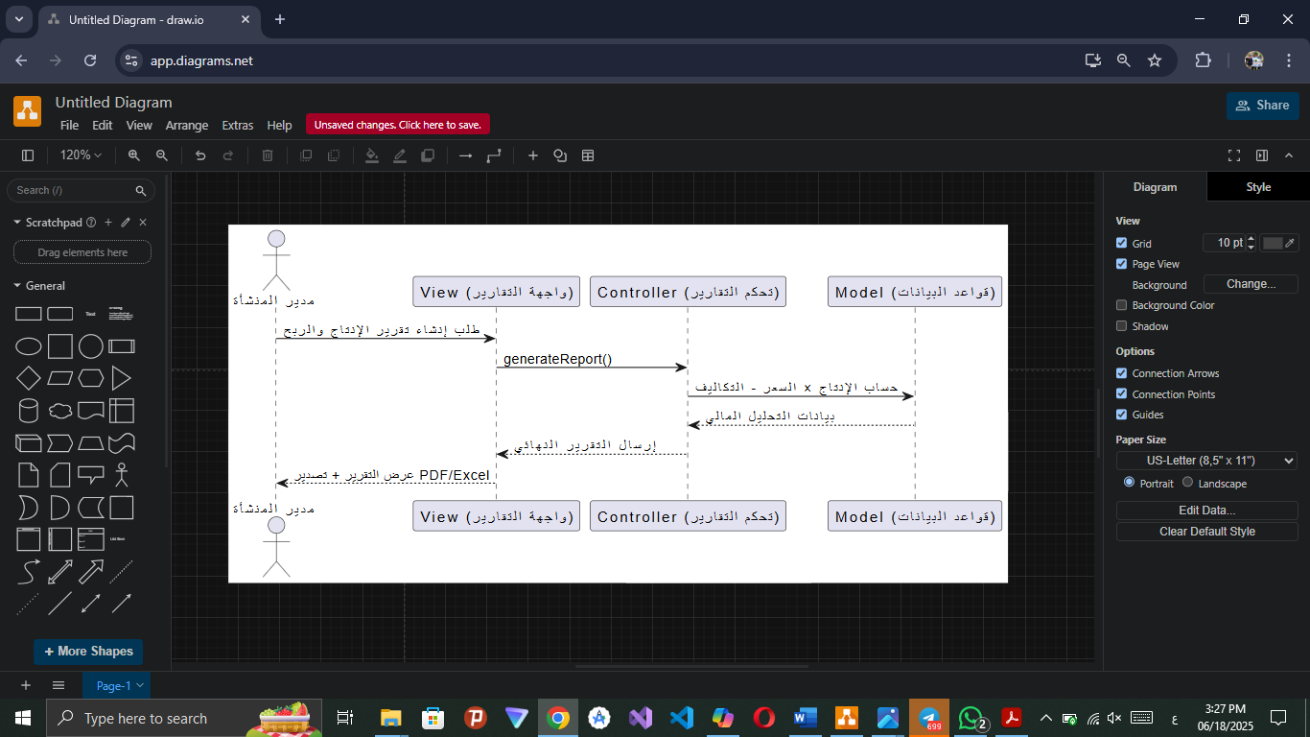
production and profit reports based on available data

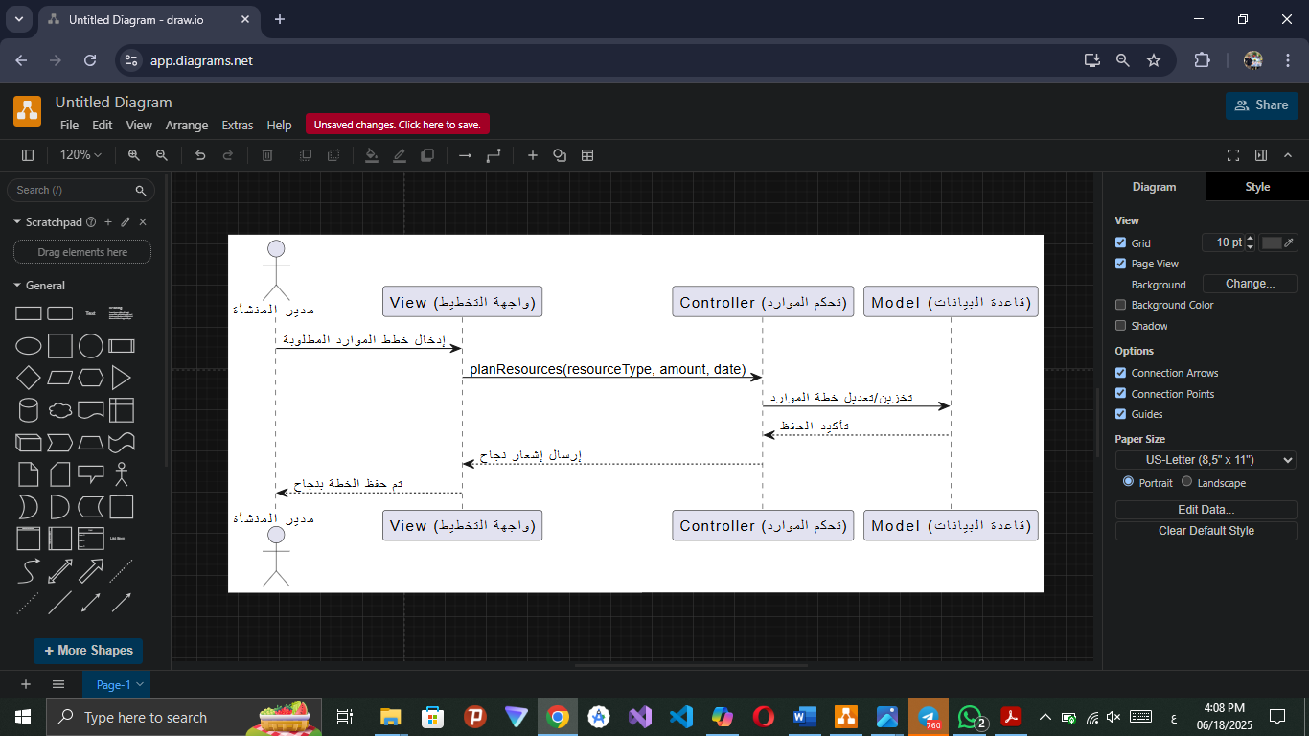
planning and scheduling resources(foodstuffs - fuel)

order food instead of food supplier

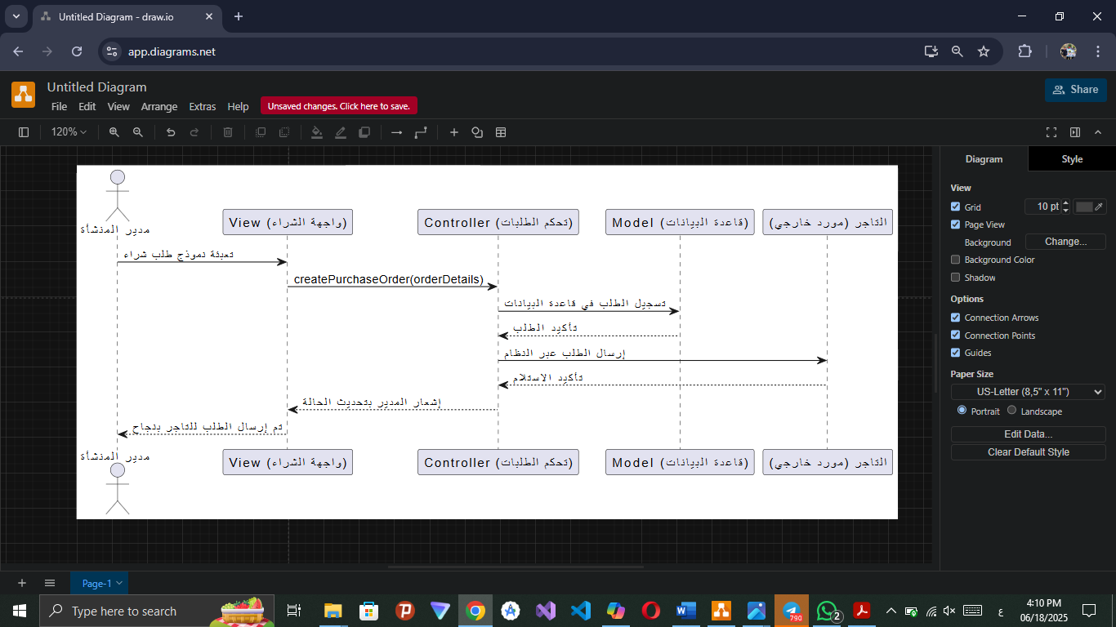

order medicines instead of Vet

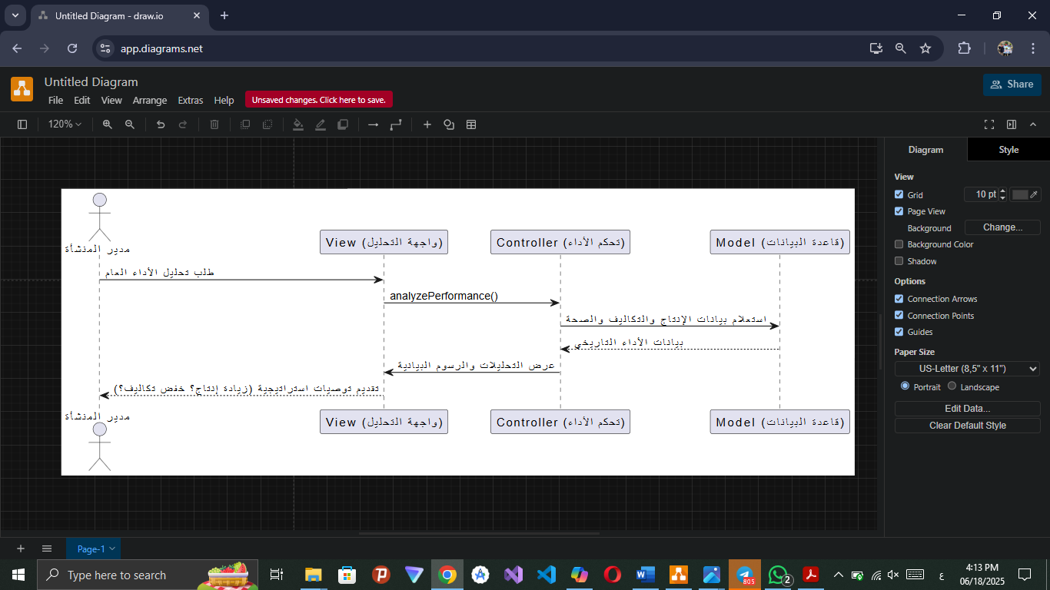
Track and analyze performance data to identify improvement opportunities and make informed decisions

Order tools instead of tool supplier

Send recommendations for improving activity reports

Send recommendations for improving productivity

Send recommendations for improving consuming facility resources

Recording veterinary examinations for individual and group cases
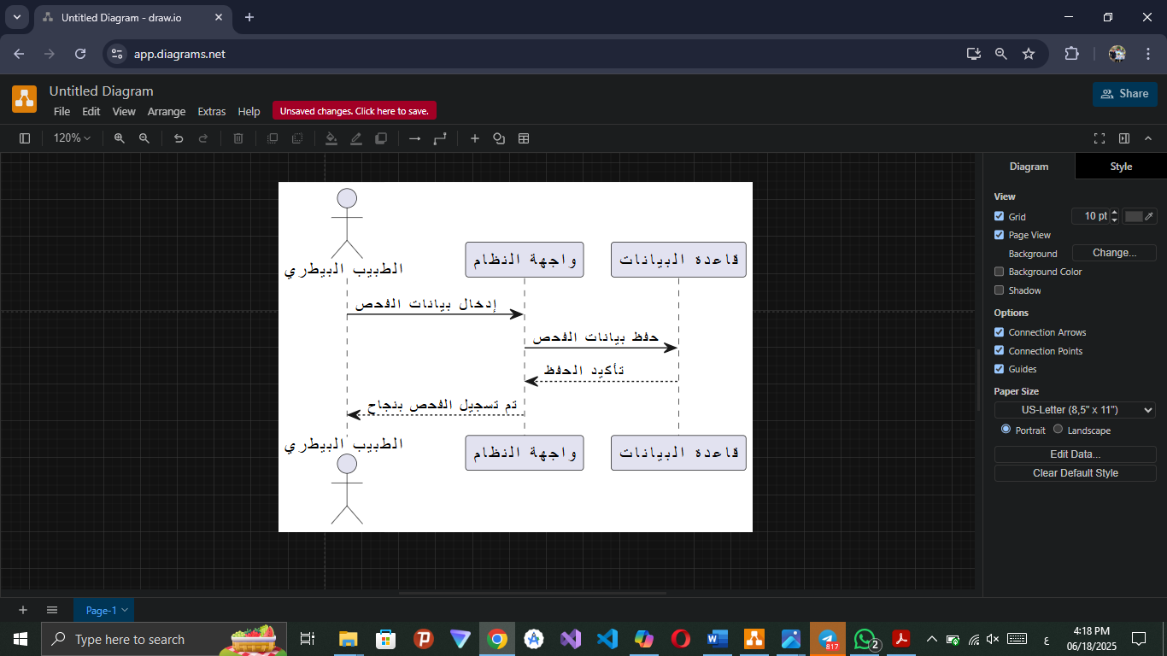

Provide specialized nutritional plans to ensure health of poultry

Display and print report history

Follow up on prevention and treatment plans
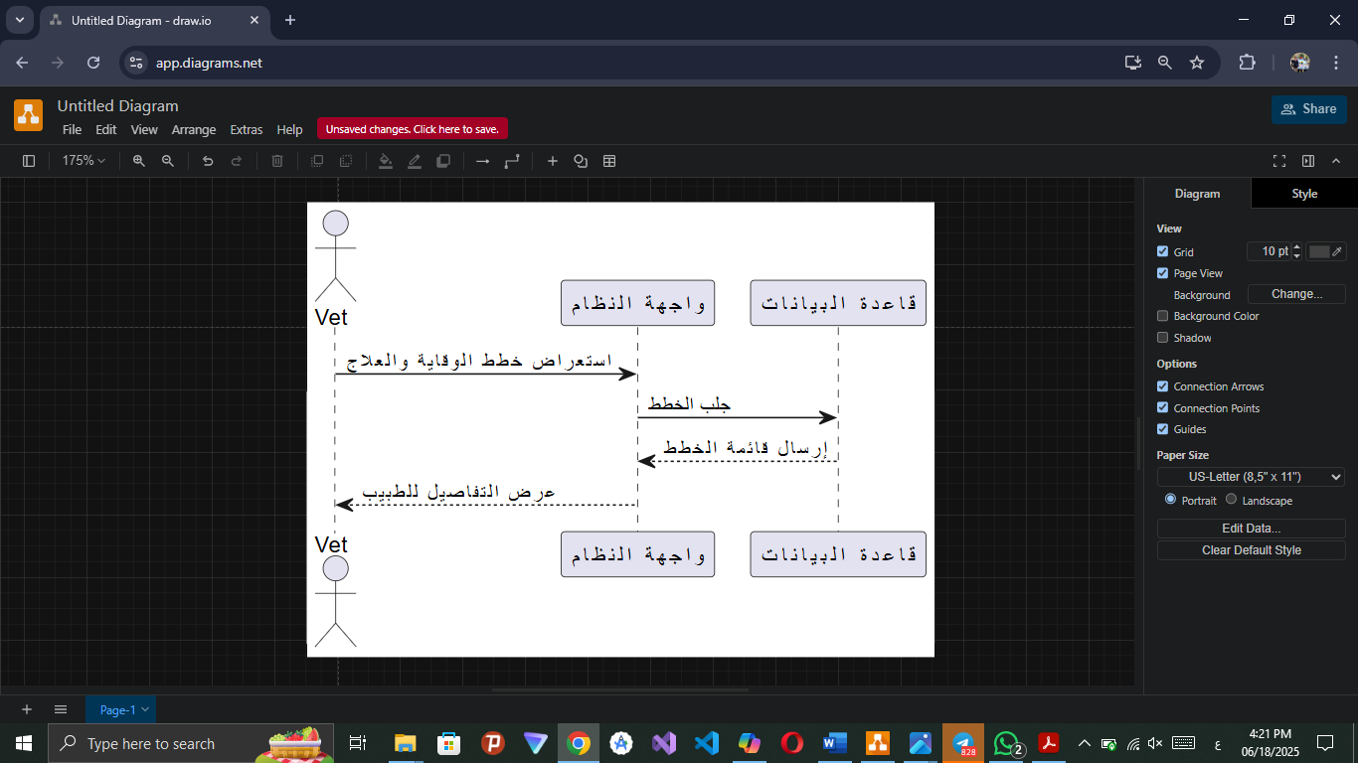

Providing recommendations to improve the health environment within the facility

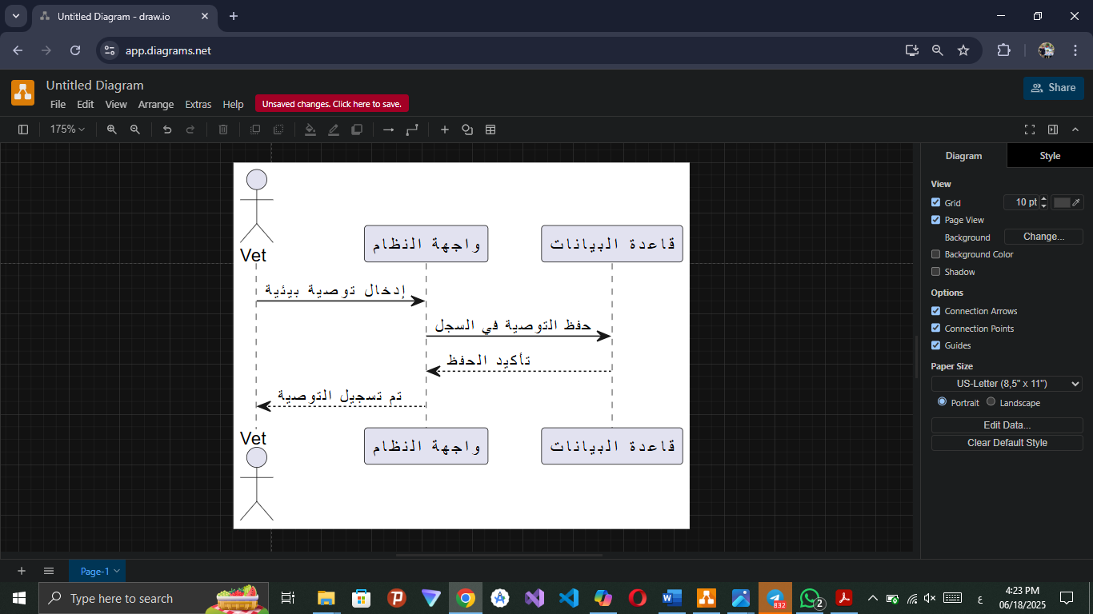

Providing specialized feeding plans to ensure the health and proper growth of poultry Appointing a new worker
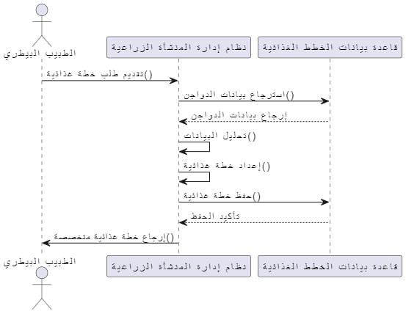

Recording daily poultry feeding data
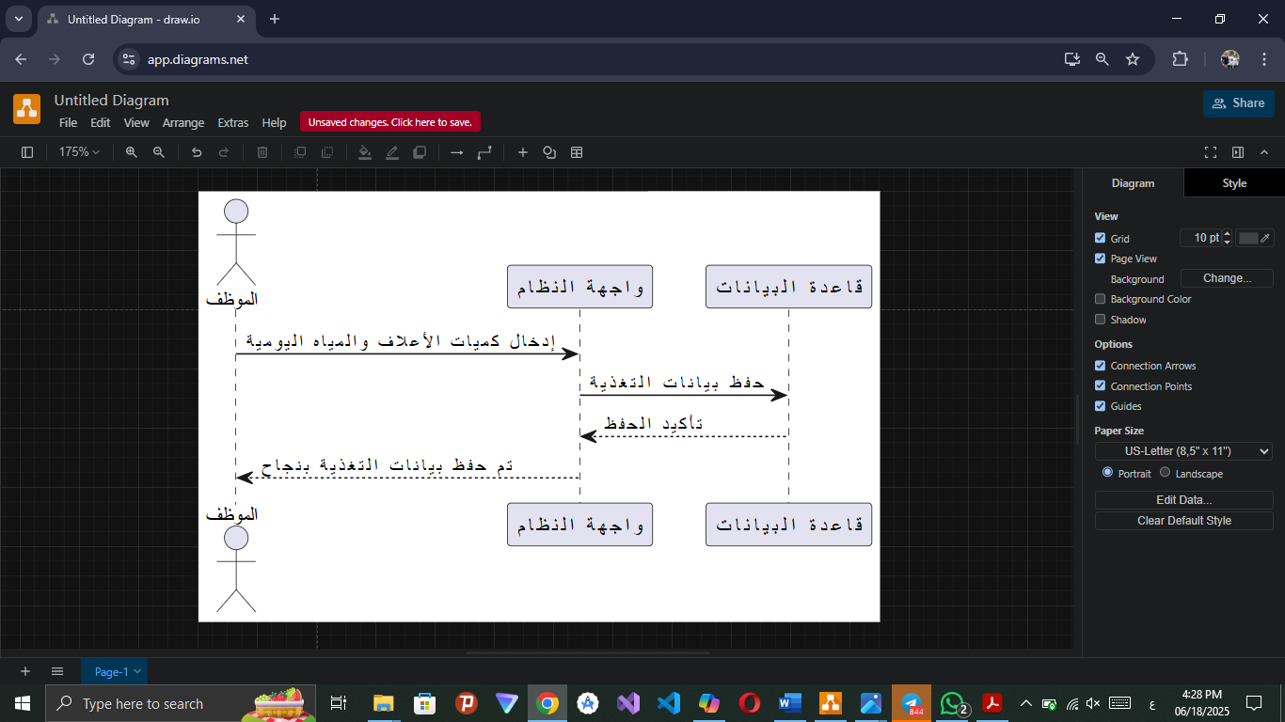

Display and print sorting and packing processes

Display and print reports from suppliers and vet

Edit reports from suppliers and vet

Reporting abnormal cases via simple forms

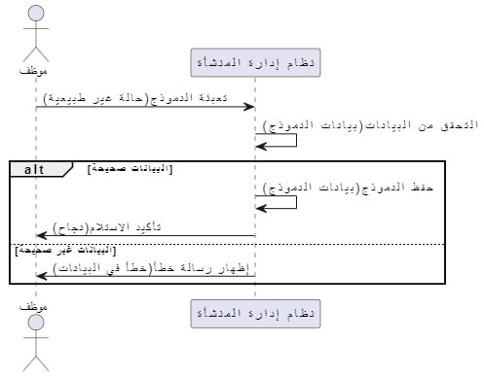

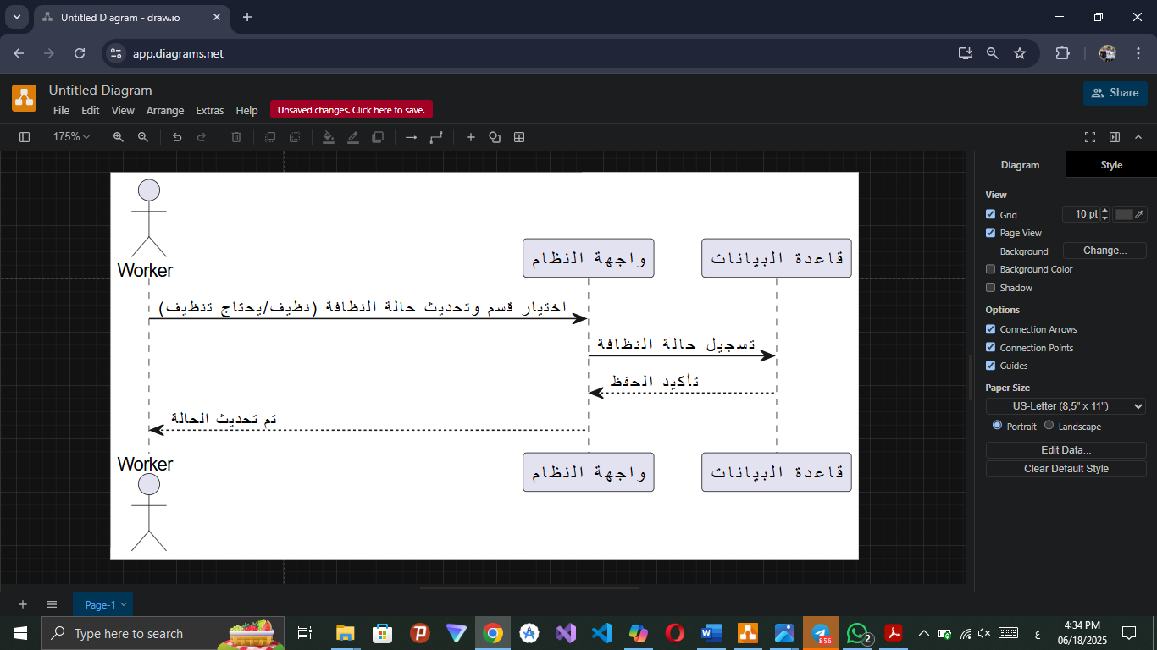
update on facility cleanliness status

Assistance with sorting and packing operations when preparing poultry for sale.

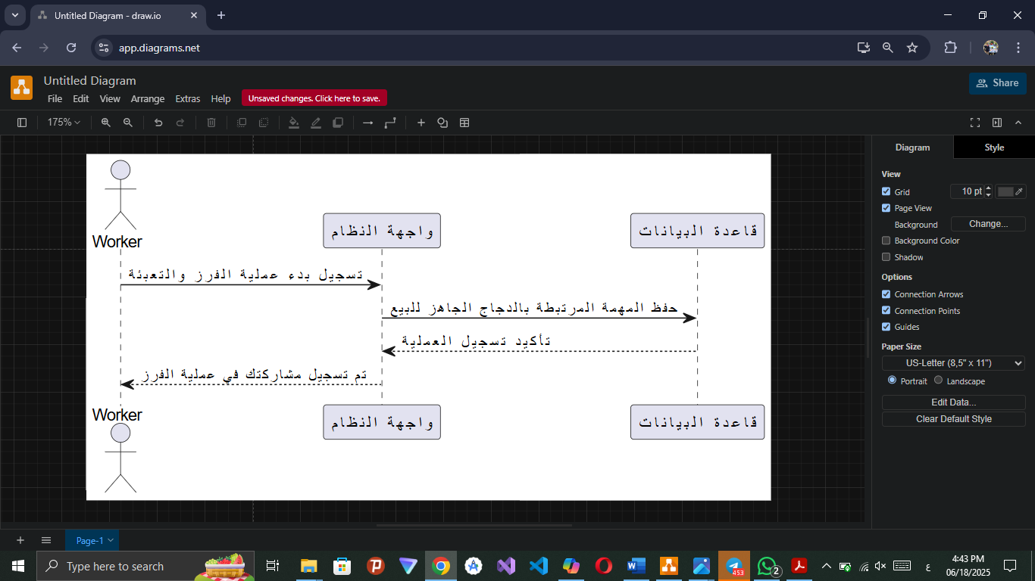

Providing price offers
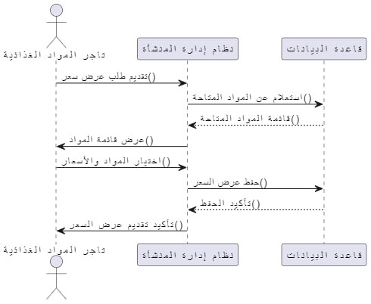

Edit and delete price offers

Provide reports about consuming food to determine future quantity

Edit, display and print food consumption reports

Update the status of orders
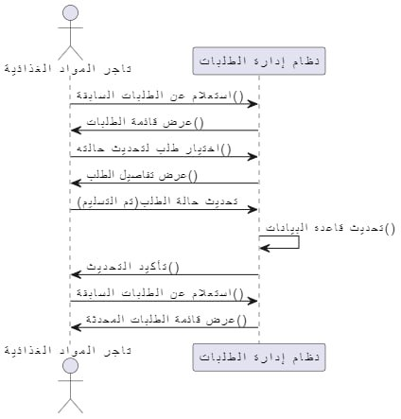

Providing food consumption reports

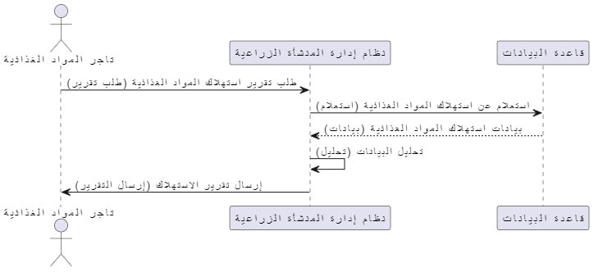

Recording the quantities of fuel supplied

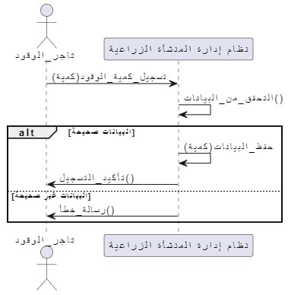

Reporting delivery problems
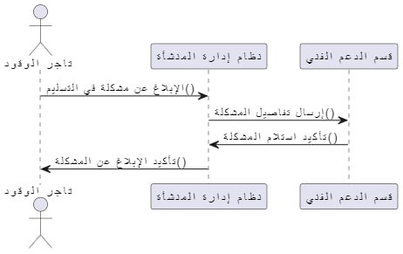

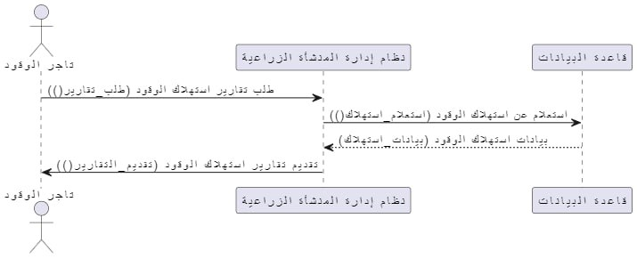
Reporting on fuel consumption

Providing recommendations for improving fuel effiency
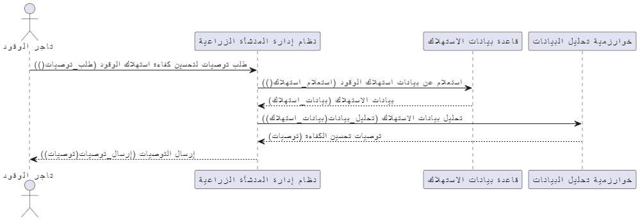

Class Diagram:
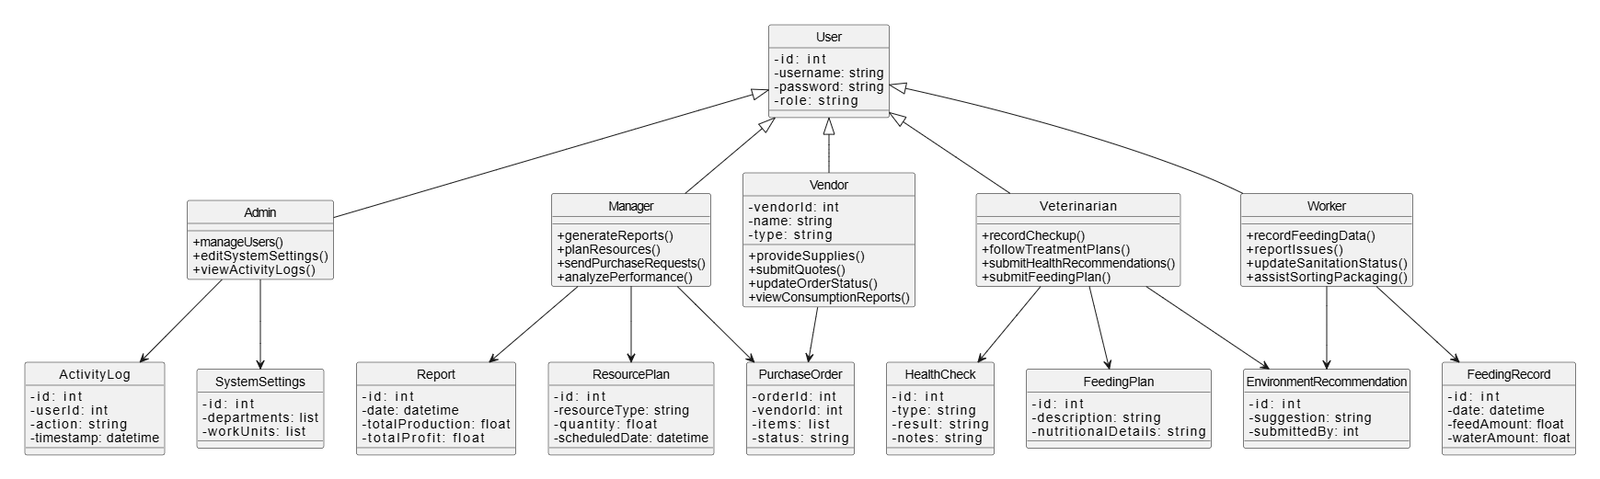

System Architecture:
System architecture refers to the overall structure and organization of components in a system. Aim to achieve goals effectively and systematically, taking into account compatibility, scalability, security, maintenance, and performance. In a poultry farming management system, it can include components such as the system frontend, database, content management system, and evaluation and analysis mechanisms.
MVC architecture is an architectural style that divides applications into three main components: Model, View, and Controller, this division aims to organize the application and facilitate its development and maintenance.

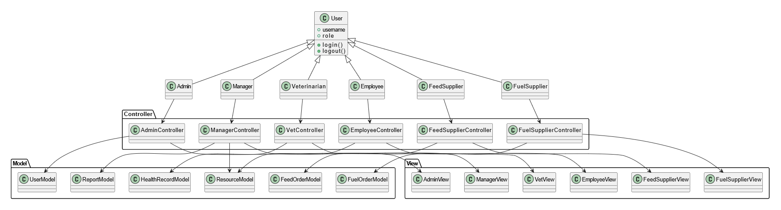

Components Diagram:
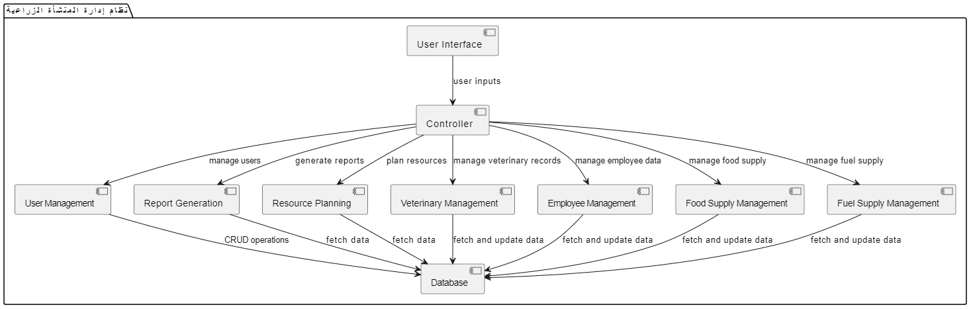

ERD Diagram:
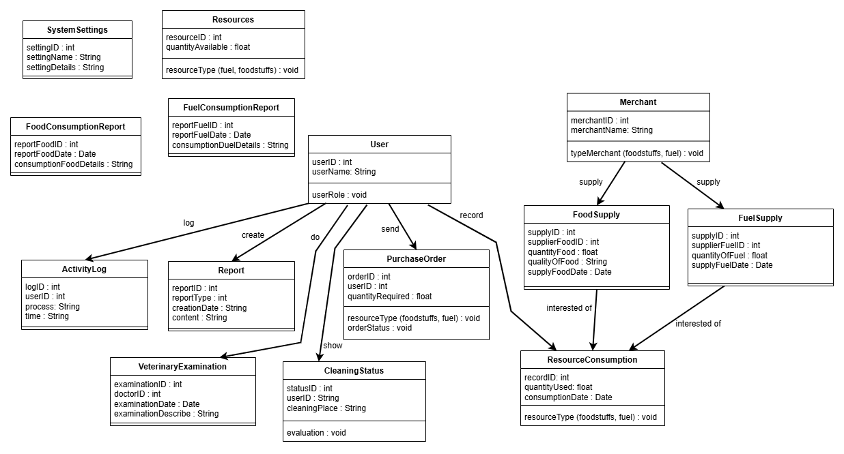

Tools Used:

draw.io: It is a free and open-source diagramming software across the platform. Its interface can be used to create diagrams such as flowcharts, wireframes, UML diagrams, org charts, and grid diagrams.

VS Code: is a script editor from Microsoft. The editor is open-source and works on Windows, macOS, and Linux. The editor is based on the Electron environment, and was launched by Microsoft in April 2015.

Postman: An application and platform for developing and testing application programming interfaces (APIs). It allows developers to send API requests, test responses, and organize API workflows in a single environment.

React: An open-source software library used to build interactive user interfaces for web applications, a JavaScript library developed by Facebook (now dead).

Node. JS: A multi-platform open-source operating environment used to run JavaScript code outside of the browser, i.e. on the server side. It was developed by Ryan Dahl in 2009 and is based on Google's JavaScript V8 engine. It allows programmers to write interactive and scalable web applications using the JavaScript language.

HTML 5: It is the fifth version of the Hypertext Markup Language (HTML), and is considered a key standard for the development of modern web pages. It was developed to improve the user experience and provide new features that support interaction and multimedia.
Benefits of using HTML5:
  - Improve user experience: With multimedia and live interaction.
  - Cross-platform compatibility: Works well on all browsers and devices.
  - Ease of use: New APIs make it easier for developers to create complex web applications.

CSS3: is the third version of the page formatting language used to design and format web pages. CSS3 introduces new and improved features that make it easier for developers to create complex and attractive designs.
Benefits of using CSS3:
- Responsive Design: CSS3 supports multimedia queries allowing web pages to be designed to adapt to different screen sizes.
- Transitions: Transitions can be used to add smooth effects when changing properties such as colors and size, improving the user experience.
- Animations: CSS3 offers the ability to create complex animations without the need to use JavaScript, reducing the load on the browser.
- Shadow and gradients: Shadows can be added to text and elements, as well as new color gradients that enhance the aesthetic of the design.
- Custom fonts: CSS3 supports importing custom fonts via @font-face, allowing designers to use unique fonts that reflect brand identity.
- Grid Layout: CSS3 provides a grid system that makes it easy to organize elements within the page flexibly and organized.

Express.js: A lightweight, fast, and open-source framework for web applications built on Node.js. It aims to streamline the process of building web applications and APIs. It is considered a backend framework and is used in the development of single, multi-page, or hybrid web applications.

MongoDB: An open-source, non-relational database (NoSQL) that uses the document model to store data.
Instead of tables and rows, MongoDB uses collections and documents, where each document stores data as key-value pairs organized in a JSON-like format, known as BSON [1,2].

Mongoose: A framework for JavaScript interaction with the MongoDB database. Mongoose provides an API for defining data diagrams, performing CRUD (create, read, update, delete) operations on data, and validating data, all using JavaScript.

Linechart Library: A library or software unit used to create line graphs. Line graphs are graphical representations of data that are linked together by lines, and are usually used to illustrate trends or changes in data over time.

Bcrypt: An encrypted hash function used to securely encrypt passwords in databases. It is based on the Blowfish algorithm and is characterized by being slow and designed to be resistant to brute force attacks. Auto-salting and iterative hashing feature is used to increase security.

Barchart Library: A powerful tool for creating bar charts in React applications, making it easy to visualize and engage data visually. The library is Chart.js-based, providing high performance and great flexibility in customizing charts.

Features of using Barchart:
- Ease of use: The library makes it quick and simple to create bar charts with an easy API.
- Flexible customization: You can adjust colors, patterns, and labels to suit your specific needs.
- Dynamic data compatibility: The library supports variable data, making it ideal for interactive web applications.
- Excellent Responsiveness: Charts work well on various devices and screens.

Tailwind css framework: Designed to make it easy to design user interfaces in a quick and flexible way. It allows developers to create custom designs without having to write CSS from scratch.
Benefits of using Tailwind css:
- Custom Design: Provides a wide range of categories (utility classes) that can be used to easily customize the design.
- Responsive Responsive: Supports responsive design using custom categories for different screen sizes.
- Easy customization: Defaults can be easily modified through the tailwind.config.js configuration file.
- High performance: Compressed CSS is produced when using tools like PurgeCSS, which reduces file size.

How to use:
- Installation: Tailwind CSS can be installed using npm:
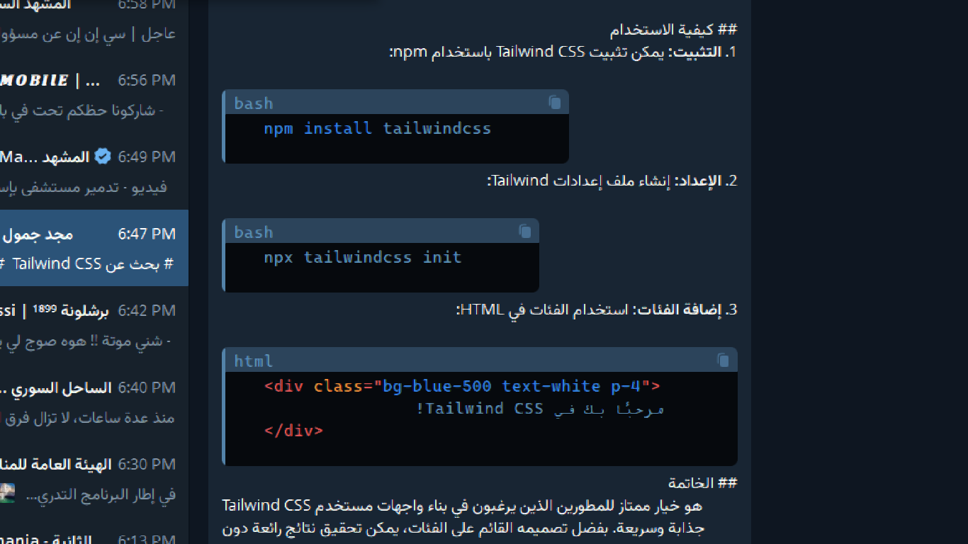

- Setup: Create a Tailwind Settings file:


- Add Categories: Use Categories in HTML:



Tests:
  - Unit Tests:

Test login with correct data

Black Box Tests | Test Type
Test.001 Req.001 | Test Case Number
Test login with correct data | Test Case Name
Ensure that the registered user has access to their account | Test Case Description
majedjammoul@gmail.com  12345678 | Input
Log in successfully | Expected output
Successful: The system detected a user with this email | Test Result

Sign in test with an unregistered email
Black Box Tests | Test Type
Test.002 Req.001 | Test Case Number
Sign in test with an unregistered email | Test Case Name
Test the system's ability to detect and attempt to log in a user who is not in the database | Test Case Description
Unregistered email and no password | Input
Error message | Expected output
Successful: The system has detected that there is no user with this incoming email | Test Result

Test for submitting a new feed requisition

Black Box Tests | Test Type
Test.003 Req.001 | Test Case Number
Test for submitting a new feed requisition | Test Case Name
Ensure the application process is successful to the food merchant | Test Case Description
Choose the type of feed, select the quantity, select the date, and click on "Submit Order" | Input
Message: "Request sent successfully" | Expected output
Successful: Request submitted successfully | Test Result

Daily feed consumption recording test
Black Box Tests | Test Type
Test.004 Req.002 | Test Case Number
Daily feed consumption recording test | Test Case Name
Ensure the accuracy of the daily nutrition data entry | Test Case Description
Enter the quantity of feed used in kilograms, specify the date, and press "Register" | Input
A message stating "Data recorded" indicates an updated quantity of available stock for this type of feed | Expected output
Successful: "Data recorded" message | Test Result

Black Box Tests | Test Type
Test.005 Req.002 | Test Case Number
Testing the feed order status update to “Delivered” | Test Case Name
Testing the merchant's ability to confirm shipment arrival | Test Case Description
Select the "pending" order from the list, and change its status to "delivered" | Input
The order status changes immediately in the manager's control panel, and a notification of shipment receipt appears | Expected output
Successful: The system was able to change the order status to "Delivered" | Test Result
Testing the feed order status update to “Delivered”

